Top 10 tips: Optimising your Market Stall for Success
After running quite a few markets, and being behind a market stall as well, here are some of our tips to what we have learnt along the way about running a successful market stall and getting the most out of your experience. This is a great tool for new stallholders, and others with more experience that might need a refresher on some tips.
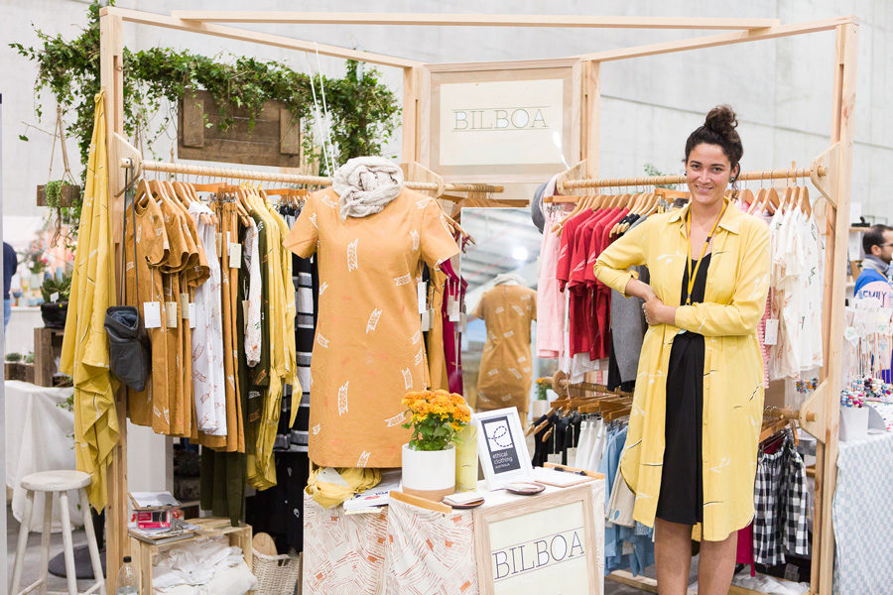
IMAGE CAPTURED BY MARK LOBO FEATURING BILBOA

1. Determining suitable product for a market environment:
First up if you are new to markets you need to consider what is right for a market stall and how to evenly distribute your product profits, as well as appealing to a range of customers.
Your product strategy should be to think about offering more than 1 item category, offer a variety of colours and styles and at varied price points. Price points ideally should be divided into 3 main categories these are:
A. Bread and Butter items – look at creating a tier price scale to draw customers in. Entry point items include products that can generate a higher turnover but might result in less profit margin.
B. Mid Range – Mid range items are those that are special yet affordable and have an even margin that means more of a profit for you and are essentially what make up the bulk of your work.
C. Highlight pieces – your highlight pieces are the ‘wow’ factor items that draw people in, they may generate less sales but with a higher profit.
So, how exactly does that look? Here is an example: If you are an artist that creates beautiful illustrations, you can sell your framed prints as your highlights, a variety of sizes of your unframed prints as your mid and cards as your bread and butter.
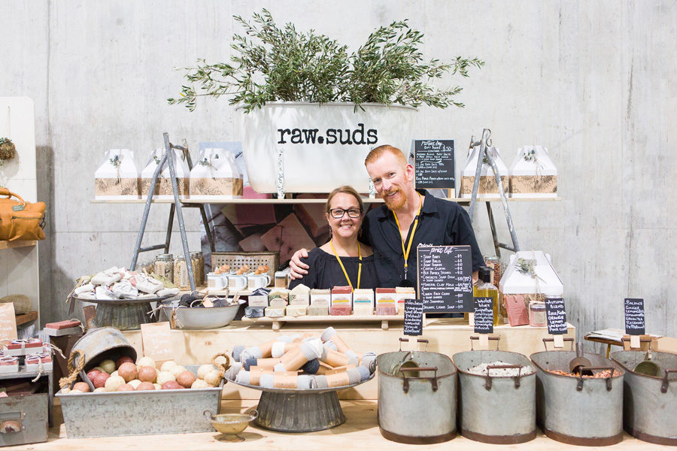
IMAGE CAPTURED BY MARK LOBO FEATURING RAW SUDS

2. Balancing your display space:
Your stall should be a welcoming and inviting space for people to be drawn to! There are many ways to make your space creative. However some practical tips are to try to balance your display so it’s at around eye level, then below and above.
If you have a table try and balance your product out so it’s a combination of height displays so that you can see everything from standing away and not just looking straight down on the table.
Make it eye catching and easy for your customers to see everything and not over accessorised or cluttered that customers have to dig around. Make items clearly visible, keep it full of product but balanced so that there is just enough product out at once.
Make products accessible so they can look at them themselves and try on, or have a closer look.
If you just have clothing racks, bring life to your area and make it inviting. Add some furniture and props, show how the product is worn, have a lookbook or images of a photoshoot ready and on display. Make it easy for customers to see and understand your product.

3. Unique displays – something to remember you by.
To make an impact to potential customers, buyers and the media – how will you impress them? Photographers will be looking for amazing things to shoot and share with the community, and bloggers are out to hunt for the best new product, shoppers are out to find something new and innovative.
Don’t forget whilst market events are about supporting the community, you are also competing with everyone there. Why would a customer buy from you and not another stall?
The best way to come up with concepts for your stall presentation is to do a bit of research. Look at other market and craft events, check out store and gallery merchandising methods and check out design blogs for inspiration. It doesn’t have to be expensive there are some simple ways of using recycled or existing items to bring some life to your stall.
If you are a regular stallholder mix up your display and try new things, people will remember if your stall looks exactly the same again and might pass on saying hello because they are looking for something new.
It’s also important that your stall reflects your product, so that it compliments your work. For example contemporary work merchandised with a vintage look stall doesn’t fit – sometimes your display draws in your customer first before the product so think about appealing to the right target market with how your stall looks.
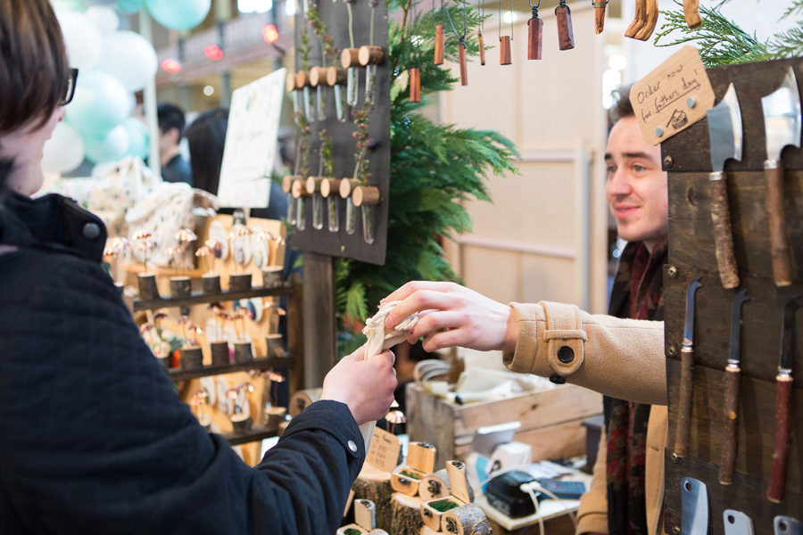
IMAGE CAPTURED BY MARK LOBO FEATURING JACCOB MCKAY
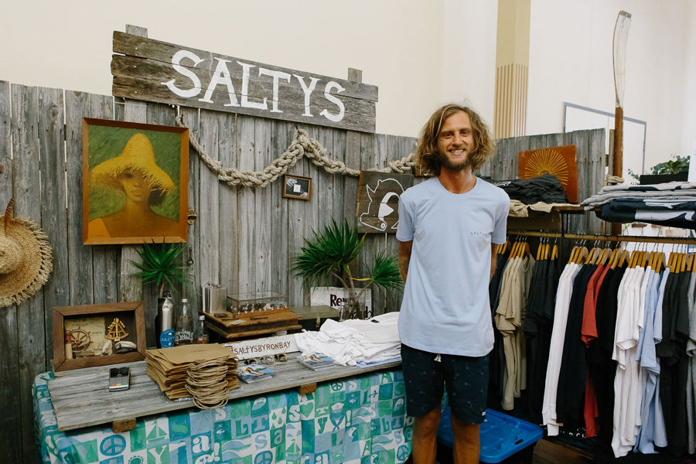
IMAGE CAPTURED BY SAMEE LAPHAM FEATURING SALTYS

4. Brand recognition – How will you be remembered?
Brand recognition is something that is often forgotten and disregarded. Why is it important? If someone is exposed to your label, but doesn’t necessarily buy it on the day – how will they remember you again?
Make sure your label name is visible throughout your stall. You can have signage or your name on your work, or labels that are visible and recognisable. It doesn’t have to be over the top if it doesn’t suit the style of your work, make it subtle.
Have postcards, business cards or promo material for customers to take away with them. Give them something to remember you from or possibly information how they can buy from you elsewhere – like online or at a shop. Sometimes the markets can be overwhelming and customers like to purchase later so make it easy for them to find you again.

4. Offer multiple payment options:
Cash is the most common way of payments at the markets but what other ways can you make it easier for your customers to pay you?
Think about hiring a mobile eftpos terminal, which gives your customer multiple payment options. If you don’t want to sign up for one, think about taking orders or offering paypal payments.
If you have options of payments make sure you let your customers know, pop a little sign on your stall so it makes it easier for them to purchase through you.
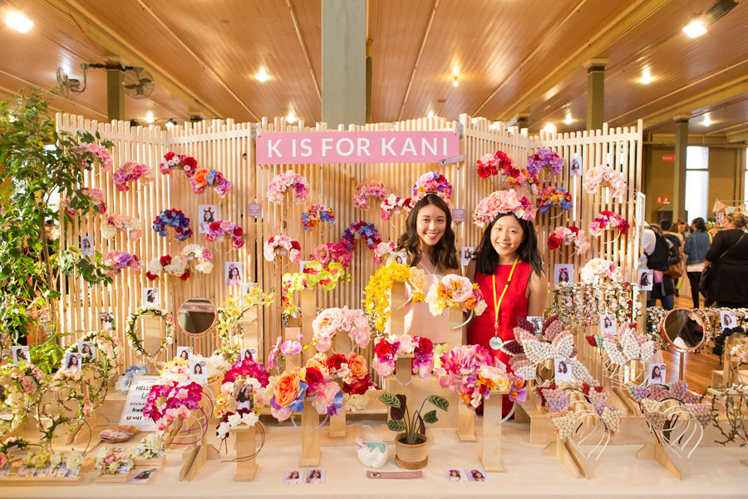
IMAGE CAPTURED BY MARK LOBO FEATURING K IS FOR KANI

5. Wear your product/ display its uses:
If your product is clothing, jewellery or accessories always wear it or get your staff/ friends to. You will be surprised at what a difference this makes as you will show the products off in the best possible way and show that you are confident about its functionality.
Other things to consider are photoshoot pictures, mannequins or heads displays to show how things are worn.
If your product isn’t worn, think about creative ways to show it uses. If it’s a tricky or unique product concept, that might need some education – think about showing them or having pictures that may help demonstrate your product.
It’s also nice for customers to know the process of how your product is made, think about showing the process or having some images or references ready for when customers ask.

6. Market specials and incentives:
Whilst you always want your product stall to look fresh exciting and new (and not like a bargain bin!) There are some classier ways that you can introduce some market deals and make potential customers feel a little special!
Think about ways you can have unique offers to new customers perhaps it’s a reduced price or special 2 for 1 – or buy a product and receive something complimentary.
Other ideas are incentives or offers – think about goody bags, gift packs, or something unique to the season you are selling it at. Eg – Mothers Day, Christmas, Valentines etc.
Always make sure that it is viable for you to offer incentives that are going to add value to your business and that you are covering your costs. Market specials are a great way to grow your customer base.
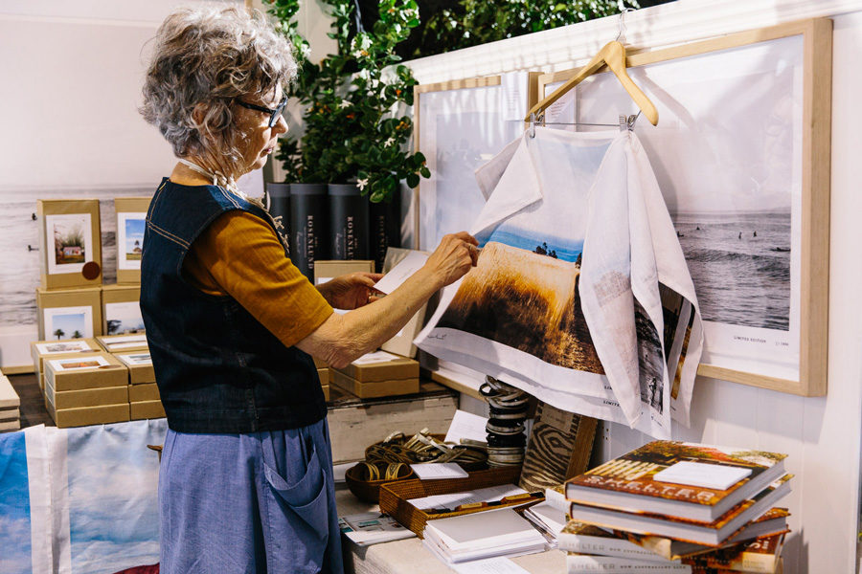
IMAGE CAPTURED BY SAMEE LAPHAM FEATURING KARA ROSENLUND

8. Attitude and Feedback:
Be approachable and always have a good attitude. Even if you are not the best at sales always make an effort to greet your customers with at very least a smile!
You need to be accommodating to potential customers, and always put your best foot forward. Customers like to feel special and that you care, they are much happier to invest their money into something that they feel connected to.
Always be respectful, courteous and grateful. You never know what customer you may have and what they could be saying about you. Your customer could spread the word and help you gain more sales, or they could potentially be a buyer or a journalist! Always be grateful for a sale. The little things customers will remember you for!
Be open to feedback. Market stalls are where you can be face to face with feedback, whether you like it or not. Sometimes it’s the best place for you to learn and see what people react to your work, other times you might hear something you might not want to.
Whilst it’s easy to get upset in this circumstances just take it on as feedback and try not to react to it. Everyone can have an opinion so be open to what they have to say.

9. Stock preparation:
Always be prepared with stock. Sizes, packaging and alternatives ready on the day. Always over compensate for what you predict will sell, so you will have left over stock ready for re-orders or possible wholesalers.
Whilst it is exciting to sell out, nothing looks worse than an empty stall!
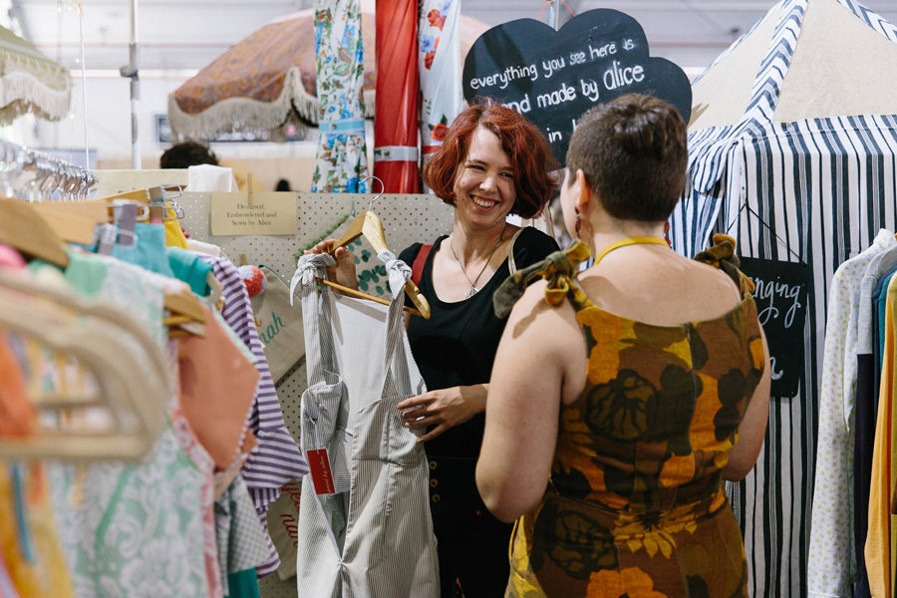
IMAGE CAPTURED BY SAMEE LAPHAM FEATURING ALICE NIGHINGALE
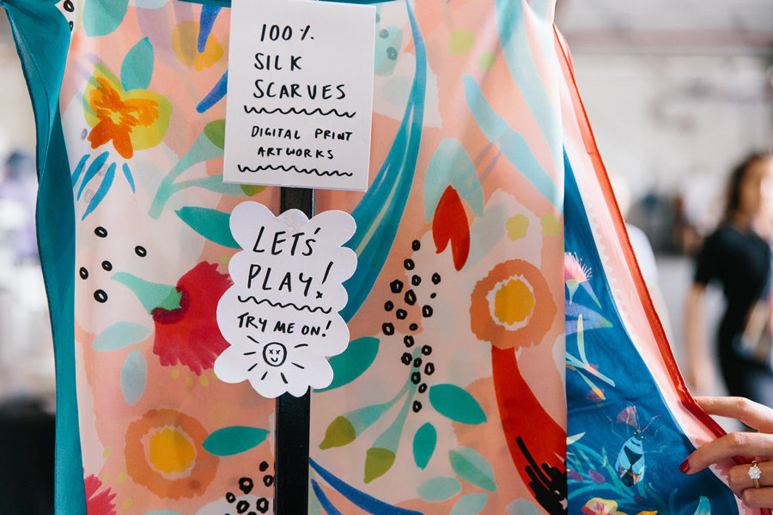
IMAGE CAPTURED BY SAMEE LAPHAM FEATURING JULIE WHITE

10. Follow up – leaving a last impression:
Last but not least! Make sure you have a way to follow up your customers, if you have a mailing list – then add a sign up sheet to your stall. If you have a website or a Facebook you want people to connect with you on, make sure your details are available at your stall and have been added to your sale.
Follow up on customers and potential orders and try and get as much feedback and connections as possible.
Being apart of markets is the best way to interact directly with your potential customer base, and also make worthwhile connections with other designers and makers that can help you support your journey.
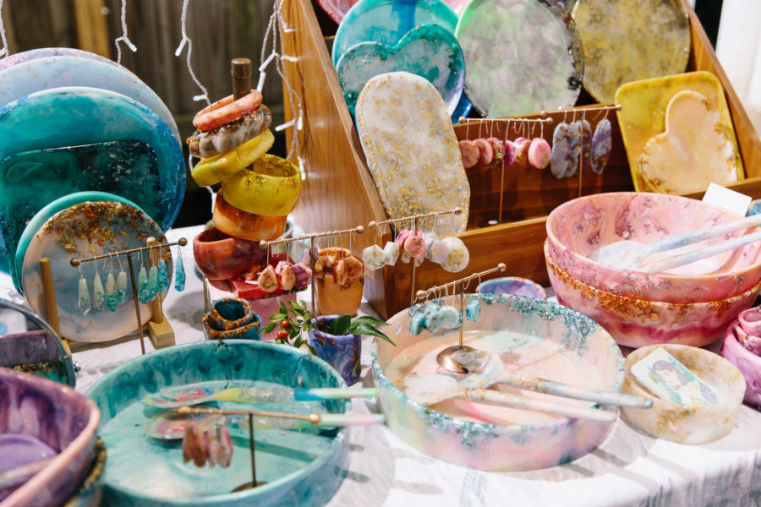
IMAGE CAPTURED BY SAMEE LAPHAM FEATURING NANNA WOO HANDMADE

