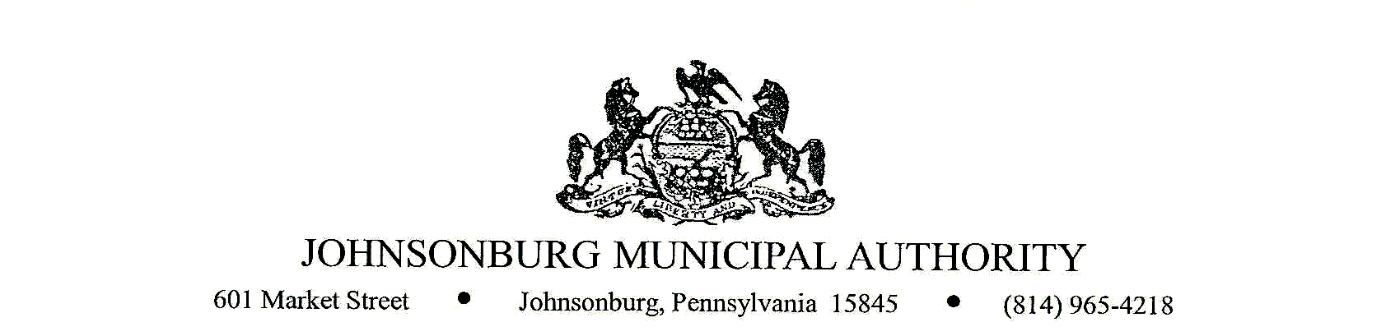
- CALL TO ORDER

- PLEDGE OF ALLEGIANCE AND MOMENT OF SILENCE

- ROLL CALL

- NOMINATION OF JMA CHAIRMAN: _____________________________

- NOMINATION OF JMA VICE CHAIRMAN: _____________________________

- NOMINATION OF JMA SECRETARY: _____________________________

- NOMINATION OF JMA TREASURER: _____________________________

- NOMINATION OF JMA ASSISTANT SECRETARY TREASURER___________________________

- NOMINATION OF SOLICITOR: _____________________________

- NOMINATION OF ENGINEER: _____________________________

- NOMINATION OF AUDITOR: _____________________________

- NOMINATION OF DEPOSITORY: _____________________________

- EXECUTIVE SESSION (if requested)
Appropriate areas of discussion are matters of personnel and employment, collective bargaining, real estate, litigation, and other matters, which if conducted in public, would violate privilege.

- APPROVAL OF MINUTES FROM PREVIOUS REGULAR MEETING ,
It is recommended that the minutes from regular meeting on December 8, 2021, be approved.

- COMMENTS FROM VISITORS ON AGENDA RELATED ITEMS ONLY (limit 2 minutes)
- MANAGER’S REPORT
- ENGINEER’S REPORT
- PROJECT ENGINEER’S REPORT
- SOLICITOR’S REPORT
- COMMITTEE REPORTS
- Administration
- Finance
- Fire Department
- Hiring
- Johnsonburg Borough
- Operations

- APPROVAL OF 2022 CHEMICALS
It is recommended that to approve __________________________ for 2022 JMA chemical supplier.

- APPROVAL OF 2022 RESTORATION
It is recommended that to approve __________________________ for 2022 JMA restoration work.

- APPROVAL OF 2022 EMERGENCY EXCAVATION
It is recommended that to approve __________________________ for 2022 JMA emergency excavation work.

- APPROVAL OF 2022 LAB WORK
It is recommended that to approve __________________________ for 2022 JMA lab work.

- APPROVAL FOR SCRUBBER
It is recommended that a scrubber for the new water plant be approved under USDA contingency funds in the amount of $6,416.95.

- APPROVAL FOR CLOTHING ALLOWANCE TO JMA STAFF
It is recommended that a yearly clothing allowance in the amount of $300.00 be approved to all JMA staff.

- APPROVAL OF $0.50 RAISE FOR ALL JMA STAFF
It is recommended that a $0.50 per hour raise be awarded to all JMA staff.

- APPROVAL TO REPURPOSE GENERATOR AT SILVER CREEK
It is recommended to repurpose the generator at the Silver Creek Water Plant. Conversation to follow on this.

- APPROVAL FOR OFFICE ADMINISTRATOR AND GENERAL MANAGER TO SIGN CHECKS
It is recommended that to approve the office administrator and general manager to sign checks for $5000.00 and under.

- APPROVAL OF TO UPGRADE SECURITY AT JMA OFFICE
It is recommended to upgrade security locks at JMA office, budgetary $2000.00.

- APPROVAL TO HIRE SCHOOL TO WORK STUDENT
It is recommended to hire school -to-work student______________@ $________________ per hour.
Start date _________________.

- APPROVAL FOR ADDITIONAL WORK ROUND 2
It is recommended to approve additional valve, hydrant and tie in work under contingency funds: $251,605.00. See attached spread sheet: Additional Work Locations.

- APPROVAL TO DONATE TO WILCOX FIRE DEPARTMENT
It is recommended to approve the donation of $20.00 to the Wilcox Volunteer Fire Department

- APPROVAL OF TREASURERS REPORT
It is recommended that the Treasurer’s report for September 2021 be approved.

- APPROVAL OF BILLS
It is recommended that the enclosed list of bills be approved as presented.
    - WATER: $63,679.14
    - WASTEWATER: $58,584.35
    - Contract No. 1 Pay App#27: $184,813.68
    - GD&F Invoice #73: $2000.00

- BUSINESS AFFAIRS

- BOARD DISCUSSION

- COMMENTS FROM VISITORS (limit 2 minutes)

- EXECUTIVE SESSION (if requested)
Appropriate areas of discussion are matters of personnel and employment, collective bargaining, real estate, litigation, and other matters, which if conducted in public, would violate privilege.

- ADJOURNMENT OF MEETING

*The next JMA Board meeting will be February 9, 2022.

