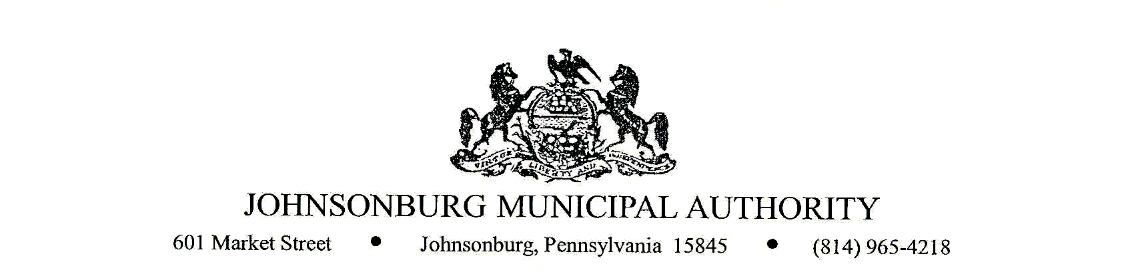
- CALL TO ORDER

- PLEDGE OF ALLEGIANCE AND MOMENT OF SILENCE

- ROLL CALL

- RAISES TO JMA STAFF
It is recommended to approve rate structure ________________________ to the JMA staff

- DISTRIBUTING SCRAP MONIES
It is recommended to approve the distribution of scrap monies to JMA staff ($747.20)

- LOAN FOR WWTP UPGRADE
It is recommended to approve financing for WWTP upgraded, contingent on bank approval.

- LOAN FOR 12 INCH LINE
It is recommended to approve financing for 12” water line upgraded, contingent on bank approval.

- EXECUTIVE SESSION (if requested)
Appropriate areas of discussion are matters of personnel and employment, collective bargaining, real estate, litigation, and other matters, which if conducted in public, would violate privilege.

- BUSINESS AFFAIRS

- BOARD DISCUSSION

- COMMENTS FROM VISITORS (limit 2 minutes)

- EXECUTIVE SESSION (if requested)
Appropriate areas of discussion are matters of personnel and employment, collective bargaining, real estate, litigation, and other matters, which if conducted in public, would violate privilege.

- ADJOURNMENT OF MEETING

*The next JMA Board meeting will be February 9, 2022.

