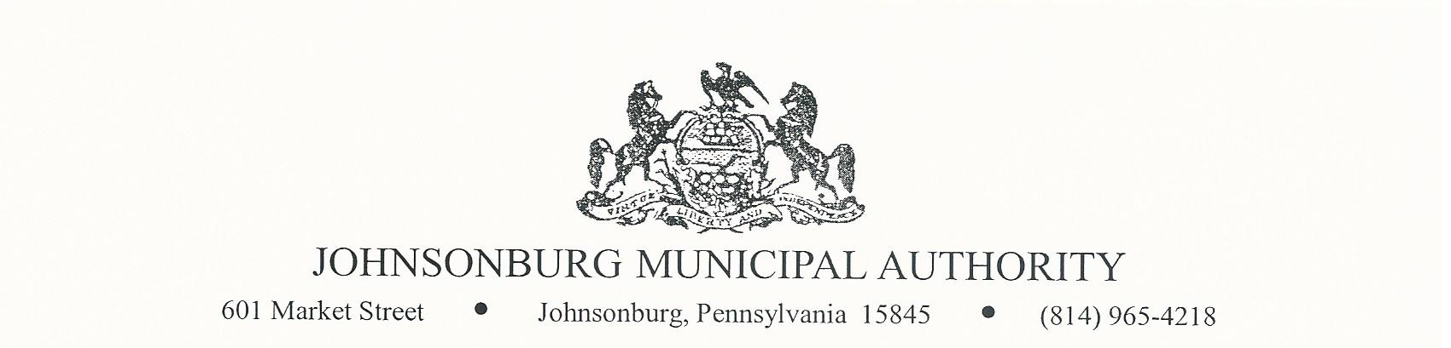**AGENDA**

**REGULAR MEETING**

**WEDNESDAY October 11, 2023**

**4:00 PM BOARD MEETING**

1. CALL TO ORDER
2. PLEDGE OF ALLEGIANCE AND MOMENT OF SILENCE
3. ROLL CALL
4. APPROVAL OF AGENDA
5. VISITORS COMMENTS on agenda items. (2-minute limit)
6. EXECUTIVE SESSION (if needed) Note: discussion is limited to Personnel, Litigation, Property, etc.
7. APPROVAL OF MINUTES FROM September 13, 2023 REGULAR MEETING
8. Manager’s Report
9. Water Report
10. Sewer Report
11. Engineer’s Report
12. Solicitor’s Report
13. Committee Reports
    * 1. Administrative
      2. Operations
      3. Finance
      4. Fire Department
      5. Hiring
      6. Johnsonburg Borough
      7. Grants
14. Treasurer’s Report

* Approve Treasurer’s Report

1. Bills for Payment

* Approve Bills for Payment in amount of $ 90,555.93

1. BOARD DISCUSSION

* 2024 Health Insurance Renewal
* $35 Elk County Foods gift certificate for employees for Thanksgiving
* Mixer for Zeigler’s tank
* Charge customers for past-due notices

1. BUSINESS AFFAIRS
2. COMMENTS FROM VISITORS
3. EXECUTIVE SESSION (If needed)
4. Adjourn