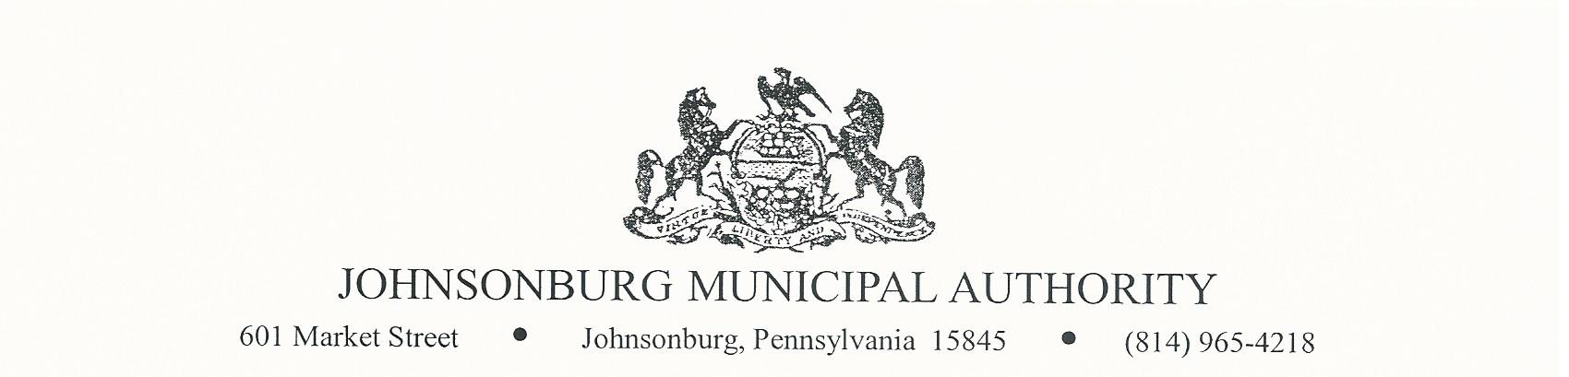**AGENDA**

**REGULAR MEETING**

**WEDNESDAY November 8, 2023**

**4:00 PM BOARD MEETING**

1. CALL TO ORDER
2. PLEDGE OF ALLEGIANCE AND MOMENT OF SILENCE
3. ROLL CALL
4. APPROVAL OF AGENDA
5. VISITORS COMMENTS on agenda items. (2-minute limit)
6. EXECUTIVE SESSION (if needed) Note: discussion is limited to Personnel, Litigation, Property, etc.
7. APPROVAL OF MINUTES FROM October 11, 2023 REGULAR MEETING
8. Manager’s Report
9. Water Report
10. Sewer Report
11. Engineer’s Report
12. Solicitor’s Report
13. Committee Reports
    * 1. Administrative
      2. Operations
      3. Finance
      4. Fire Department
      5. Hiring
      6. Johnsonburg Borough
      7. Grants
14. Treasurer’s Report

* Approve Treasurer’s Report

1. Bills for Payment

* Approve Bills for Payment in amount of $ 86,039.36

1. BOARD DISCUSSION

* Charge customers for past-due notices

1. BUSINESS AFFAIRS

* Open bids for generators

1. COMMENTS FROM VISITORS
2. EXECUTIVE SESSION (If needed)
3. Adjourn