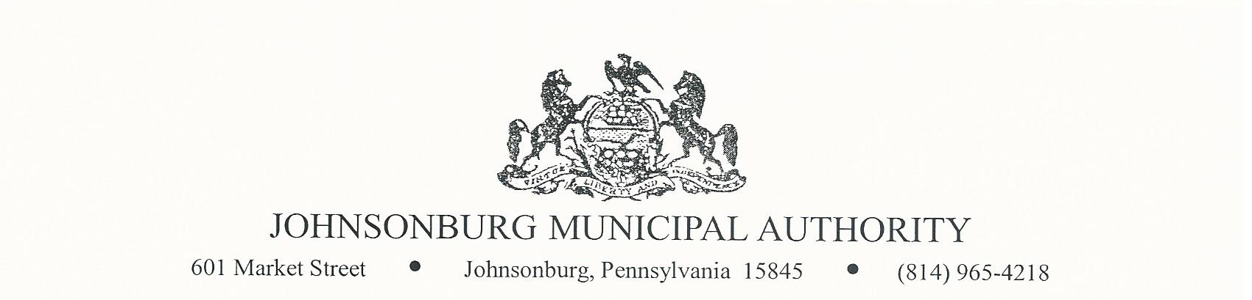**AGENDA**

**REGULAR MEETING**

**WEDNESDAY December 13, 2023**

**4:00 PM BOARD MEETING**

1. CALL TO ORDER
2. PLEDGE OF ALLEGIANCE AND MOMENT OF SILENCE
3. ROLL CALL
4. APPROVAL OF AGENDA
5. VISITORS COMMENTS on agenda items. (2-minute limit)
6. EXECUTIVE SESSION (if needed) Note: discussion is limited to Personnel, Litigation, Property, etc.
7. APPROVAL OF MINUTES FROM November 8, 2023 REGULAR MEETING
8. Manager’s Report
9. Water Report
10. Sewer Report
11. Engineer’s Report
12. Solicitor’s Report

* Easement for Nittany Mart

1. Committee Reports
   * 1. Administrative
     2. Operations
     3. Finance
     4. Fire Department
     5. Hiring
     6. Johnsonburg Borough
     7. Grants
2. Treasurer’s Report

* Approve Treasurer’s Report

1. Bills for Payment

* Approve Bills for Payment in amount of $ 101,850.17

1. BOARD DISCUSSION

* Charge customers for past-due notices

1. BUSINESS AFFAIRS

* Adopt/Approve Grant Resolutions for both Cedar Street Watermain Replacement and Clarion Road Watermain Replacement
* Approval of 2024 meeting dates: Jan. 10, Feb. 14, Mar. 13, Apr. 10, May 8, Jun. 12,

Jul. 10, Aug. 14, Sept. 11, Oct. 9, Nov. 13, Dec. 11

* Discuss advertising for bids for 2024, if deemed necessary

1. COMMENTS FROM VISITORS
2. EXECUTIVE SESSION (If needed)
3. Adjourn