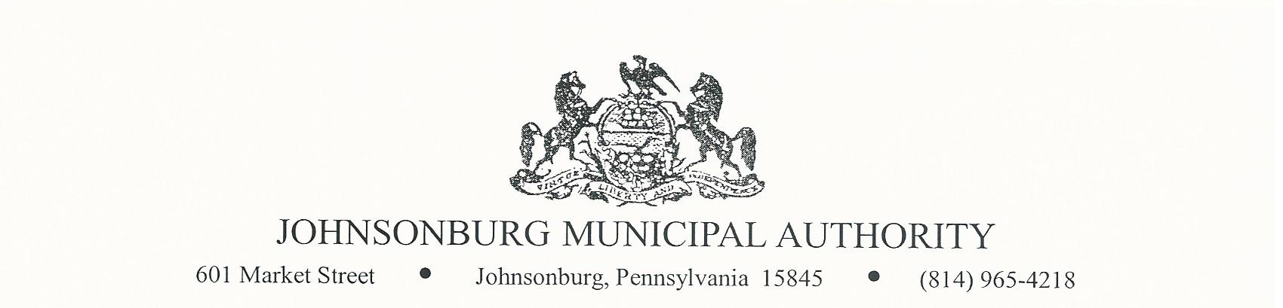**REGULAR MEETING**

**WEDNESDAY FEBRUARY 8th/2023**

**4:00 PM BOARD MEETING**

1. CALL TO ORDER
2. PLEDGE OF ALLEGIANCE AND MOMENT OF SILENCE
3. ROLL CALL
4. VISITORS COMMENTS on agenda items. (2 minute limit)
5. EXECUTIVE SESSION (IF NEEDED) Note: discussion is limited to Personnel, Litigation, Finance.
6. APPROVAL OF MINUTES FROMPREVIOUS REGULAR MEETINGS

December 15, 29, and January 11

1. Manager’s Report
2. Water Report
3. Sewer Report
4. Engineer’s Report
5. Solicitor’s Report
6. Committee Reports
   * 1. Administrative
     2. Operations
     3. Finance
     4. Fire Department
     5. Hiring
     6. Johnsonburg Borough
     7. Grants
7. Treasurer’s Report

Approve Bills and Financial Statement for December and January

1. Bills for Payment
2. BOARD DISCUSSION
   1. Billing Problems with delayed reads
   2. Request for TJ Weaver to attend conference
3. BUSINESS AFFAIRS

Quote from ACS for Microsoft Office 365 Renewal

1. COMMENTS FROM VISITORS
2. EXECUTIVE SESSION (If Needed)
3. Adjourn