**AGENDA**

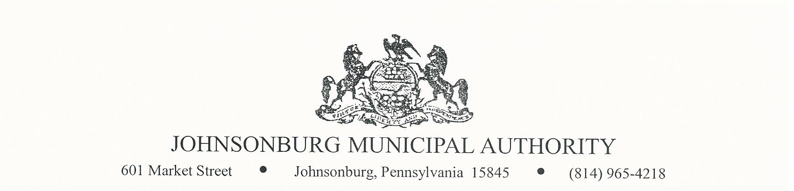

**SPECIAL MEETING**

**Wednesday April 26, 2023**

**4:45 PM BOARD MEETING**

1. CALL TO ORDER
2. PLEDGE OF ALLEGIANCE AND MOMENT OF SILENCE
3. ROLL CALL
4. APPROVAL OF AGENDA
5. VISITORS COMMENTS on agenda items. (2 minute limit)
6. EXECUTIVE SESSION (IF NEEDED) Note: discussion is limited to Personnel, Litigation, Property, etc.
7. BOARD DISCUSSION
   1. Trucks – Finance or outright purchase of new truck and accessories

Roll Call Vote: ____ Ayes ______ Nays ______ Abstain _______

|  |  |  |
| --- | --- | --- |
| Mr. Zeigler: | Mr. Weaver: | Mr. Villella |
| Mr. DePanfilis | Mr. Poague | Mr. Park |
|  | Mr. Fowler: |  |

* 1. Sell old trucks

Roll Call Vote: ____ Ayes ______ Nays ______ Abstain _______

|  |  |  |
| --- | --- | --- |
| Mr. Zeigler: | Mr. Weaver: | Mr. Villella |
| Mr. DePanfilis | Mr. Poague | Mr. Park |
|  | Mr. Fowler: |  |

1. BUSINESS AFFAIRS
   1. Rates for overages (requested by a Board Member)
   2. Other business properly presented to the Board of Directors
2. COMMENTS FROM VISITORS
3. EXECUTIVE SESSION (If Needed)
4. Adjourn