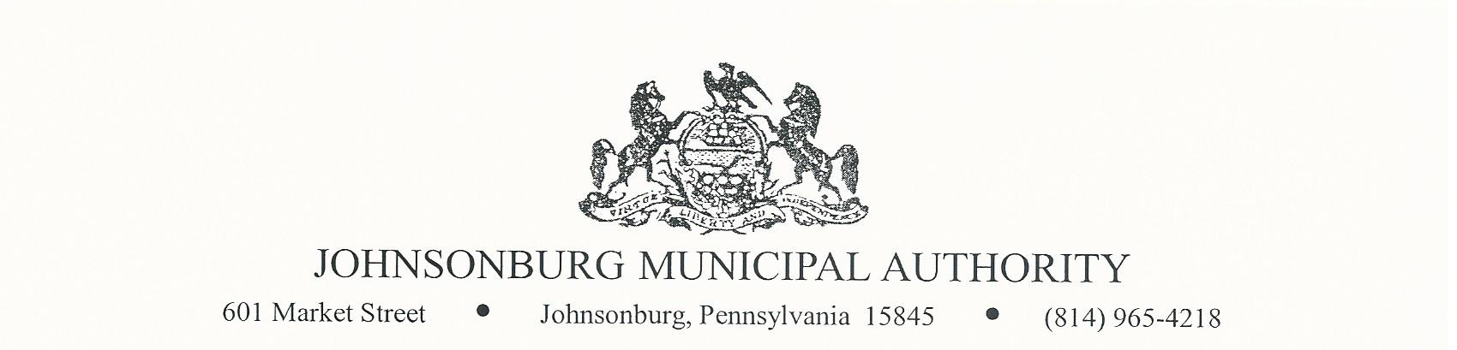**AGENDA**

**REGULAR MEETING**

**WEDNESDAY June 14, 2023**

**4:00 PM BOARD MEETING**

1. CALL TO ORDER
2. PLEDGE OF ALLEGIANCE AND MOMENT OF SILENCE
3. ROLL CALL
4. APPROVAL OF AGENDA
5. VISITORS COMMENTS on agenda items. (2 minute limit)
6. EXECUTIVE SESSION (IF NEEDED) Note: discussion is limited to Personnel, Litigation, Property, etc.
7. APPROVAL OF MINUTES FROM MAY 10,2023 REGULAR MEETING
8. Manager’s Report
9. Water Report
10. Sewer Report
11. Engineer’s Report
12. Solicitor’s Report
13. Committee Reports
    * 1. Administrative
      2. Operations
      3. Finance
      4. Fire Department
      5. Hiring
      6. Johnsonburg Borough
      7. Grants
14. Treasurer’s Report
    * + - Approve Treasurer’s Reports from May and June meetings
15. Bills for Payment
    * + - Approve Bills for Payment
16. BOARD DISCUSSION
    1. Additional federal holidays and other time off to match the borough employees
    2. Pay business insurance policy premium annual to save $ 2,329/year
    3. JMA shirts for new employees
    4. Customers Christopher Wright and Becky Richards bill issues
    5. Update security camera access
    6. Fire hydrant at the Community Building will not work with the fire dept. hoses
    7. Rate increase
17. BUSINESS AFFAIRS
18. COMMENTS FROM VISITORS
19. EXECUTIVE SESSION (If Needed)
20. Adjourn