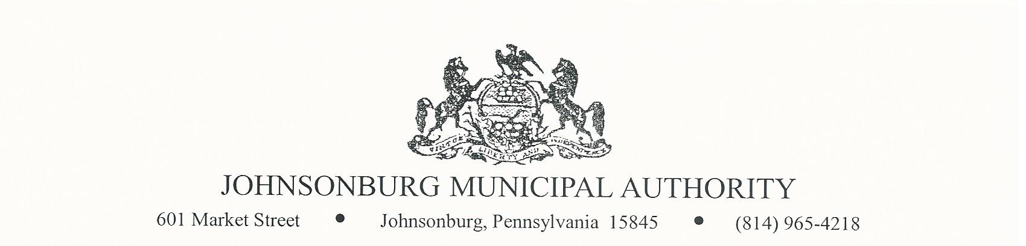**AGENDA**

**REGULAR MEETING**

**WEDNESDAY August 16, 2023**

**4:00 PM BOARD MEETING**

1. CALL TO ORDER
2. PLEDGE OF ALLEGIANCE AND MOMENT OF SILENCE
3. ROLL CALL
4. APPROVAL OF AGENDA
5. VISITORS COMMENTS on agenda items. (2 minute limit)
6. EXECUTIVE SESSION (IF NEEDED) Note: discussion is limited to Personnel, Litigation, Property, etc.
7. APPROVAL OF MINUTES FROM July 12, 2023 REGULAR MEETING
8. Manager’s Report
9. Water Report
10. Sewer Report
11. Engineer’s Report
12. Solicitor’s Report
13. Committee Reports
    * 1. Administrative
      2. Operations
      3. Finance
      4. Fire Department
      5. Hiring
      6. Johnsonburg Borough
      7. Grants
14. Treasurer’s Report
    * + - Approve Treasurer’s Report
15. Bills for Payment
    * + - Approve Bills for Payment in amount of $ 84,088.66
16. BOARD DISCUSSION
17. BUSINESS AFFAIRS
18. COMMENTS FROM VISITORS
19. EXECUTIVE SESSION (If Needed)
20. Adjourn