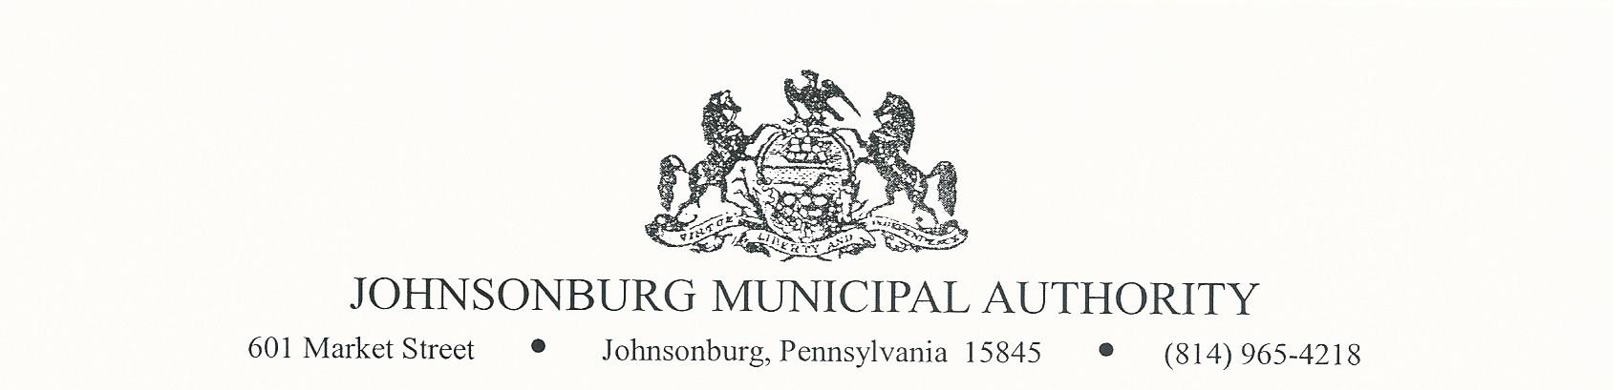

REGULAR MEETING
Wednesday August 11, 2021
4:00 PM Board Meeting

AGENDA

- CALL TO ORDER

- PLEDGE OF ALLEGIANCE AND MOMENT OF SILENCE

- ROLL CALL

- EXECUTIVE SESSION (if requested)
Appropriate areas of discussion are matters of personnel and employment, collective bargaining, real estate, litigation and other matters, which if conducted in public, would violate privilege.

- APPROVAL OF MINUTES FROM PREVIOUS REGULAR MEETING

It is recommended that the minutes from regular meeting on July 14, 2021 be approved.
Motion __________________ Second ____________________

Roll Call Vote: ____ Ayes ______ Nays ______ Abstain _______

Mr. Zeigler: | Mr. Weaver: | Mr. Reinsburrow:
Mr. Polaski: | Mr. Park:
Mr. Destephano: | Mr. Asti:

- APPROVAL OF MINUTES FORM SPECIAL MEETING

It is recommended that the minutes form special meeting on July 23, 2021 be approved.

Motion __________________ Second ____________________

Roll Call Vote: ______ Ayes ______ Nays ______ Abstain _______

Mr. Zeigler: | Mr. Weaver: | Mr. Reinsburrow:
Mr. Polaski: | Mr. Park:
Mr. Destephano: | Mr. Asti:

- COMMENTS FROM VISITORS ON AGENDA RELATED ITEMS ONLY (limit 2 minutes)
- MANAGER’S REPORT
- ENGINEER’S REPORT
- PROJECT ENGINEER’S REPORT
- SOLICITOR’S REPORT
- COMMITTEE REPORTS
- Administration
- Finance
- Fire Department
- Hiring
- Johnsonburg Borough
- Operations

- DISCUSSION OF A MONTHLY STIPEND FOR CELL PHONES

It is recommended to approve a monthly stipend to JMA staff for cell phone use.
Salary $___________
Hourly $___________

Motion __________________ Second ____________________

Roll Call Vote: ______ Ayes ______ Nays ______ Abstain _______

Mr. Zeigler: | Mr. Weaver: | Mr. Reinsburrow:
Mr. Polaski: | Mr. Park:
Mr. Destephano: | Mr. Asti:

- DISCUSSION FOR WORK APPARELL – SHIRTS. PROFESSIONAL LOOK FOR CREW IN THE FIELD

It is recommended to approve apparel to field staff.

Motion __________________ Second ____________________

Roll Call Vote: ______ Ayes ______ Nays ______ Abstain _______

Mr. Zeigler: | Mr. Weaver: | Mr. Reinsburrow:
Mr. Polaski: | Mr. Park:
Mr. Destephano: | Mr. Asti:

- ACCOUNTS OVER $350.00 IN ARREARAGES WILL BE SHUT OFF UNTIL PAID IN FULL

It is recommended to approve shut offs to accounts over $350.00 in arrearages.

Motion __________________ Second ____________________

Roll Call Vote: ______ Ayes ______ Nays ______ Abstain _______

Mr. Zeigler: | Mr. Weaver: | Mr. Reinsburrow:
Mr. Polaski: | Mr. Park:
Mr. Destephano: | Mr. Asti:

- APPROVAL TO GO TO BI-WEEKLY PAY ROLL JANUARY 2022

It is recommended to approve to move to bi-weekly payroll January 2022.

Motion __________________ Second ____________________

Roll Call Vote: ______ Ayes ______ Nays ______ Abstain _______

Mr. Zeigler: | Mr. Weaver: | Mr. Reinsburrow:
Mr. Polaski: | Mr. Park:
Mr. Destephano: | Mr. Asti:

- APPROVAL OF TREASURERS REPORT

It is recommended that the Treasurer’s report for July 2021 be approved.

Motion __________________ Second ____________________

Roll Call Vote: ______ Ayes ______ Nays ______ Abstain _______

Mr. Zeigler: | Mr. Weaver: | Mr. Reinsburrow:
Mr. Polaski: | Mr. Park:
Mr. Destephano: | Mr. Asti:

- APPROVAL OF BILLS

It is recommended that the enclosed list of bills be approved as presented.

    - WATER:

Motion __________________ Second ____________________

Roll Call Vote: ____ Ayes ______ Nays ______ Abstain _______

Mr. Zeigler: | Mr. Weaver: | Mr. Reinsburrow:
Mr. Polaski: | Mr. Park:
Mr. Destephano: | Mr. Asti:

    - WASTEWATER:

Motion __________________ Second ____________________

Roll Call Vote: ____ Ayes ______ Nays ______ Abstain _______

Mr. Zeigler: | Mr. Weaver: | Mr. Reinsburrow:
Mr. Polaski: | Mr. Park:
Mr. Destephano: | Mr. Asti:

    - Project Engineer:

Motion __________________ Second ____________________

Roll Call Vote: ____ Ayes ______ Nays ______ Abstain _______

Mr. Zeigler: | Mr. Weaver: | Mr. Reinsburrow:
Mr. Polaski: | Mr. Park:
Mr. Destephano: | Mr. Asti:

    - CONTRACT NO. 1 PAY APPLICATION:

Motion __________________ Second ____________________

Roll Call Vote: ____ Ayes ______ Nays ______ Abstain _______

Mr. Zeigler: | Mr. Weaver: | Mr. Reinsburrow:
Mr. Polaski: | Mr. Park:
Mr. Destephano: | Mr. Asti:

    - CONTRACT NO. 3 PAY APPLICATION:

Motion __________________ Second ____________________

Roll Call Vote: ____ Ayes ______ Nays ______ Abstain _______

Mr. Zeigler: | Mr. Weaver: | Mr. Reinsburrow:
Mr. Polaski: | Mr. Park:
Mr. Destephano: | Mr. Asti:

    - CONTINGENCY ITEMS, JMA REQUISITION #71:

Motion __________________ Second ____________________

Roll Call Vote: ____ Ayes ______ Nays ______ Abstain _______

Mr. Zeigler: | Mr. Weaver: | Mr. Reinsburrow:
Mr. Polaski: | Mr. Park:
Mr. Destephano: | Mr. Asti:

- BUSINESS AFFAIRS

- BOARD DISCUSSION

- COMMENTS FROM VISITORS (limit 2 minutes)

- EXECUTIVE SESSION (if requested)
Appropriate areas of discussion are matters of personnel and employment, collective bargaining, real estate, litigation and other matters, which if conducted in public, would violate privilege.

- ADJOURNMENT OF MEETING

Motion __________________ Second ____________________

Roll Call Vote: ___ Ayes ______ Nays ______ Abstain _______

Mr. Zeigler: | Mr. Weaver: | Mr. Reinsburrow:
Mr. Polaski: | Mr. Park:
Mr. Destephano: | Mr. Asti:

*The next JMA Board meeting will be September 8, 2021.

