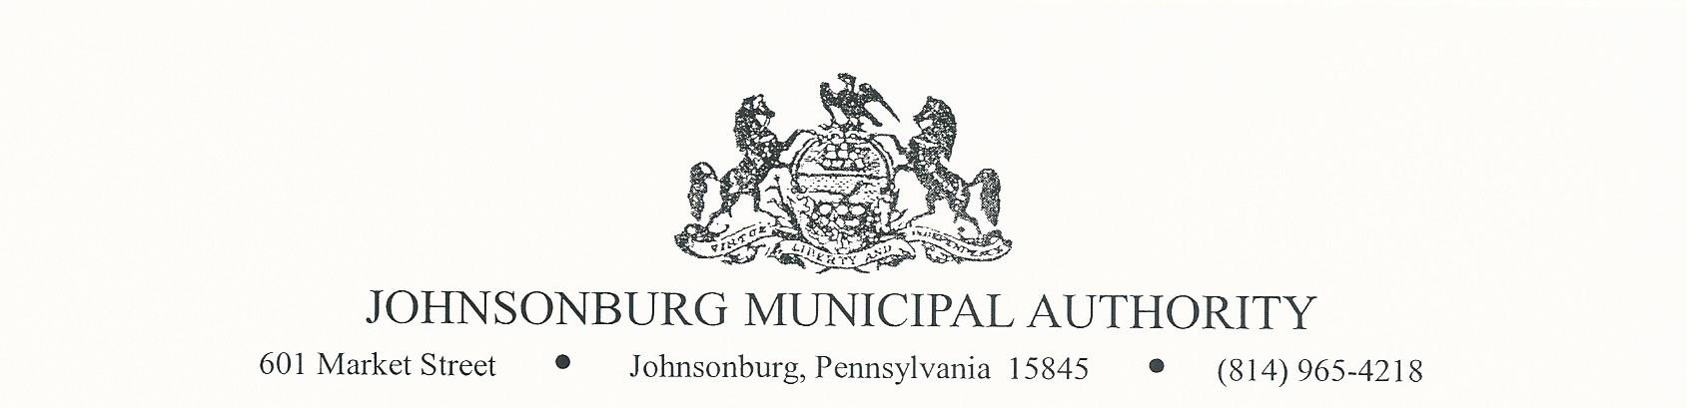

SPECIAL MEETING
Monday August 23, 2021
3:00 PM Board Meeting

AGENDA

- CALL TO ORDER

- PLEDGE OF ALLEGIANCE AND MOMENT OF SILENCE

- ROLL CALL

- EXECUTIVE SESSION (if requested)
Appropriate areas of discussion are matters of personnel and employment, collective bargaining, real estate, litigation and other matters, which if conducted in public, would violate privilege.

- APPROVAL OF 3RD MODIFICATION OF CONSENT ORDER

It is recommended that the 3rd modification of the consent order be approved, time extension.
Motion __________________ Second ____________________

Roll Call Vote: ____ Ayes ______ Nays ______ Abstain _______

Mr. Zeigler: | Mr. Weaver: | Mr. Reinsburrow:
Mr. Polaski: | Mr. Park:
Mr. Destephano: | Mr. Asti:

- COMMENTS FROM VISITORS ON AGENDA RELATED ITEMS ONLY (limit 2 minutes)

- ADJOURNMENT OF MEETING

Motion __________________ Second ____________________

Roll Call Vote: ___ Ayes ______ Nays ______ Abstain _______

Mr. Zeigler: | Mr. Weaver: | Mr. Reinsburrow:
Mr. Polaski: | Mr. Park:
Mr. Destephano: | Mr. Asti:

*The next JMA Regular Board meeting will be September 8, 2021.

