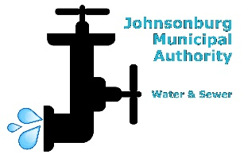
JOHNSONBURG MUNICIPAL AUTHORITY
SPECIAL MEETING
FRIDAY, JULY 23, 2021

The meeting was called to order at 9:00 AM by Chairman James Reinsburrow followed by the Pledge of Allegiance and a moment of silence.

ROLL CALL – In attendance were James Reinsburrow, Charles DeStephano, Dennis Asti, Kenneth Polaski, Thomas J. Weaver, Dan Newell. Excused - Richard Zeigler and Earl Park. Richard Brown, Esq. via ZOOM.

VISITORS – Al Maletto representing The Johnsonburg Press

EXECUTIVE SESSION – Motion was made by Thomas J. Weaver and seconded by Kenneth Polaski to enter executive session at 9:01 AM to discuss personnel. Motion carried unanimously. Personnel discussion in Executive session to hire a temporary employee for meter related work. Motion was made by Charles DeStephano and seconded by Kenneth Polaski to exit executive session at 9:18 AM. Motion carried unanimously. Motion made by Charles DeStephano and seconded by Thomas J. Weaver to enter regular session at 9:19 AM

APPROVAL TO HIRE A TEMPORARY EMPLOYEE
Hiring of Robert Kennedy for temporary work, motion was made by Charles DeStephano and seconded by Kenneth Polaski. Role Call Vote: 3: AYES, 2: NAYES
Mr. Zeigler – EXCUSED, Mr. Weaver – NO, Mr. Reisburrow – YES, Mr. Polaski – YES, Mr. Park – EXCUSED, Mr. DeStephano – YES, Mr. Asti – NO.

BOARD DISCUSSION
None

MOTION TO ADJOURN
Motion by Charles DeStephano and seconded by Thomas J. Weaver to adjourn at 9:21 AM. Motion carried by unanimous vote of members present.

VISITORS – Richard Brown, Esq. via ZOOM, Al Maletto representing himself and the Johnsonburg Press

VISITOR COMMENTS – None

Kenneth Polaski,
Secretary
DJN

