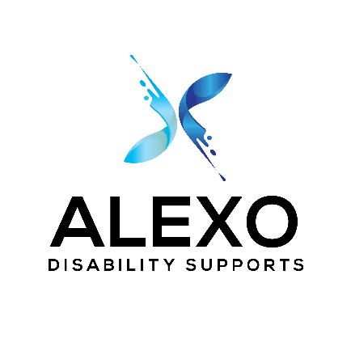
Alexo Disability Supports NDIS Intake Form

This form is for new referrals only. This is so we can determine which services you require and how best to support you.
1300 663 004
Return this form to: hello@alexodisabilitysupports.com.au
Referrer Name: | Mobile no:
Email: | Relationship to participant:
Participant name: | NDIS number:
Preferred name: | Email:
Mobile no: | Date of birth
Address: | Preferred method of communication:
Is your plan:  - Self-Managed  - Plan Managed  - Agency Managed | Current living situation:
Is there a current Behaviour Support Plan?  - Yes  - No | Language spoken at home:  Is English a second language?  Is an interpreter required?
Current diagnosis: | Are there any issues that may affect your ability to engage supports?
Which of our services are you interested in?  - Recovery Coaching  - Support Coordination Level 2  - Specialist Support Coordination  - Counselling  - Social Work Therapeutic supports | Please email this form and any additional documents such as the following:  - NDIS plan  - Diagnostic letters  - Information on plan nominee  - Representative information / agreements  - Any information you feel may be relevant
Date of referral: | Signature of referrer:

