Contact Information:  Main DAA Website:  www.daausa.org  SFL Region DAA Email:  SouthFlAreaDAA  @gmail.com  For additional information about DAA meetings or opportunities for service:  Maureen 772-708-1179  Derek C. 561-289-9817  Updated: August, 2022 |  | Contacts: |  |  | 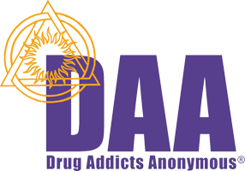  Where & When  South Florida DAA  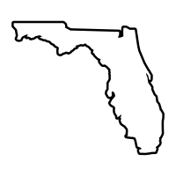

MEETINGS:  LAHIA DAA  DAY: MONDAY TIME: 6:00 PM  Love and Hope In Action  1760 SE Salerno Road  Stuart, FL 34997  A New Take on Life  DAY: WEDNESDAY TIME: 7:30 PM  Alternatives Motorcycle Club  6960 Heritage Drive  Port St. Lucie, FL 34952  No Name Group  DAY: THURSDAY TIME: 7:00 PM  2000 SE Port Saint Lucie Blvd  Port St. Lucie, Fl 34952  A Way Out  DAY: THURSDAY TIME: 7:30 PM  Bayshore Club  8545 South US HWY 1  Port Saint Lucie, FL 34952  The Firing Line  DAY: FRIDAY TIME: 7:30 PM  Bayshore Club  8545 South US HWY 1  Port Saint Lucie, FL 34952  The New Freedom Group  DAY: SATURDAY TIME: 7:30  Alternatives Motorcycle Club  6960 Heritage Dr, Port St. Lucie, FL 34952  DAF-ANON (Fellowship of Families & Friends of an addicted loved one)  DAY: SATURDAY TIME: 10:00 AM  Bayshore Club  8545 South US HWY 1  Port Saint Lucie, FL 34952 | What is the History of DAA?  ​  The first DAA group was formed in Sweden in 1997 based on the program of Alcoholics Anonymous. While AA focuses primarily on alcoholism, DAA was formed as a separate fellowship to offer the same, successful program specifically to drug addicts while adhering to AA’s Traditions. DAA was granted permission from AA World Services to adopt the Twelve Steps and Twelve Traditions as a program of recovery. The only changes made to the Twelve Steps were substituting the word “alcohol” with “narcotics and all other mind-altering substances” and “alcoholics” with “drug addicts”. DAA uses the book “Alcoholics Anonymous” (AA’s “Big Book”) as the basic text, substituting drugs for alcohol and addiction for alcoholism. The first DAA group was formed in the USA in 2007 and can now be found all over the U.S., as well as England, Norway, Sweden and Denmark. | What is DAA?  ​Drug Addicts Anonymous is a fellowship of men and women who have recovered from addiction and are committed to helping those who still suffer. We have recovered by using the Twelve Steps as outlined in the book of Alcoholics Anonymous.  DAA is not allied with any sect, denomination, politics, organization or institution, does not engage in any controversy, and neither endorses nor opposes any causes. Our primary purpose is to recover from our addiction and help other addicts to achieve the same freedom. DAA is not dedicated to users of any one specific drug, and use of no single drug was predominant among our members.  Are there any dues or fees?  No. DAA is fully supported by voluntary contributions from its members and declines outside donations.  ​  DAA Does Not:  ​Keep attendance records.  Monitor or control members.  Recruit or solicit members.  Provide detox, rehab, hospitalization, medication, or psychiatric treatment.  Offer religious services.  Dispense food, clothing, jobs, money, or other social services.  Provide letters of reference to parole boards, lawyers, or courts.

