Cambridge Commercial Club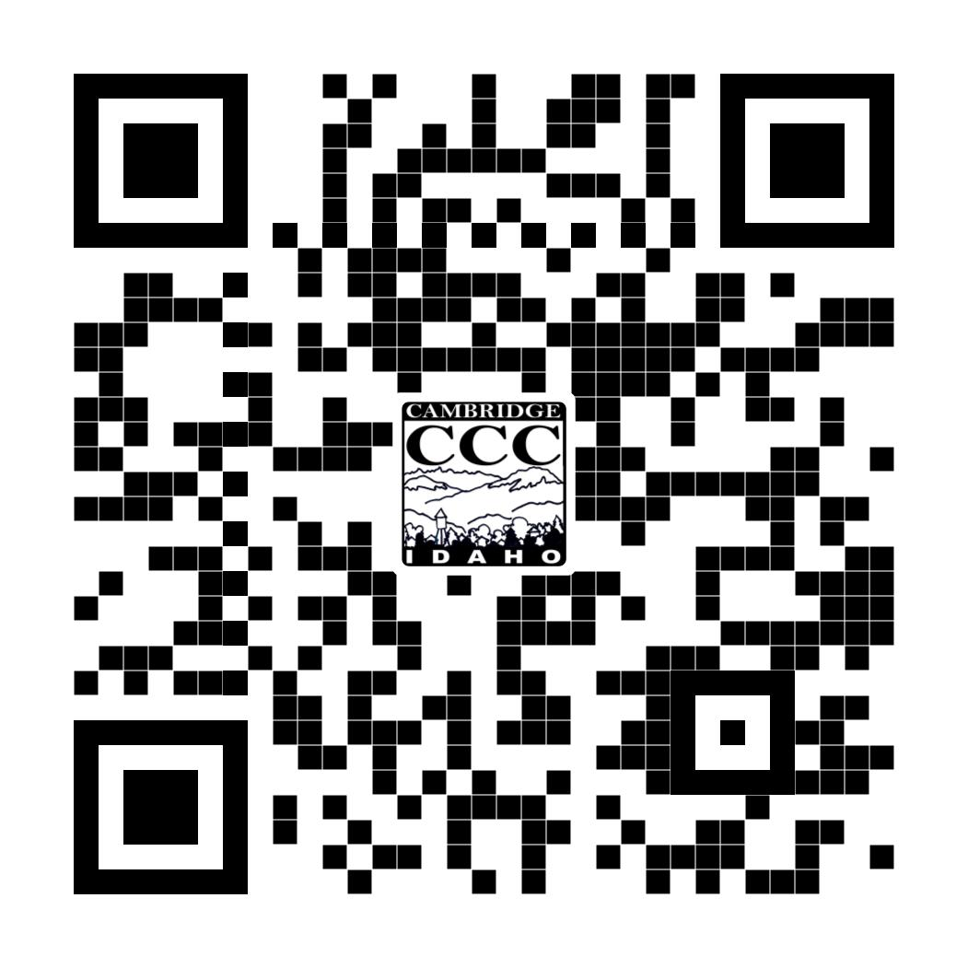
P.O. Box 54 • Cambridge, ID 83610
Phone (208) 257-3533
www.cambridgeidaho.com
www.facebook.com/cambridgeidaho
2022 Membership Application
NEW or RENEWAL (circle one)
DATE

BUSINESS NAME OR INDIVIDUAL NAME

ADDRESS, CITY, STATE, ZIP

BUSINESS PHONE, CELL PHONE

EMAIL ADDRESS

BUSINESS WEBSITE ADDRESS

COMPANY REPRESENTATIVE

DESCRIPTION OF BUSINESS

Does your business have (circle all that apply)?
GOOGLE BUSINESS LISTING FACEBOOK PAGE INSTAGRAM ACCOUNT LOGO
2022 Membership Dues - $40 (Make Checks Payable to Cambridge Commercial Club)

Mail Form and Payment to – Cambridge Commercial Club PO BOX 54 Cambridge, Idaho 83610

If you are a New Member please email your logo and business listing information to cambridgeidaho@gmail.com

If you have any questions or need additional information, contact Brandie Lincoln at 208-257-4564 or cambridgeidaho@gmail.com.

