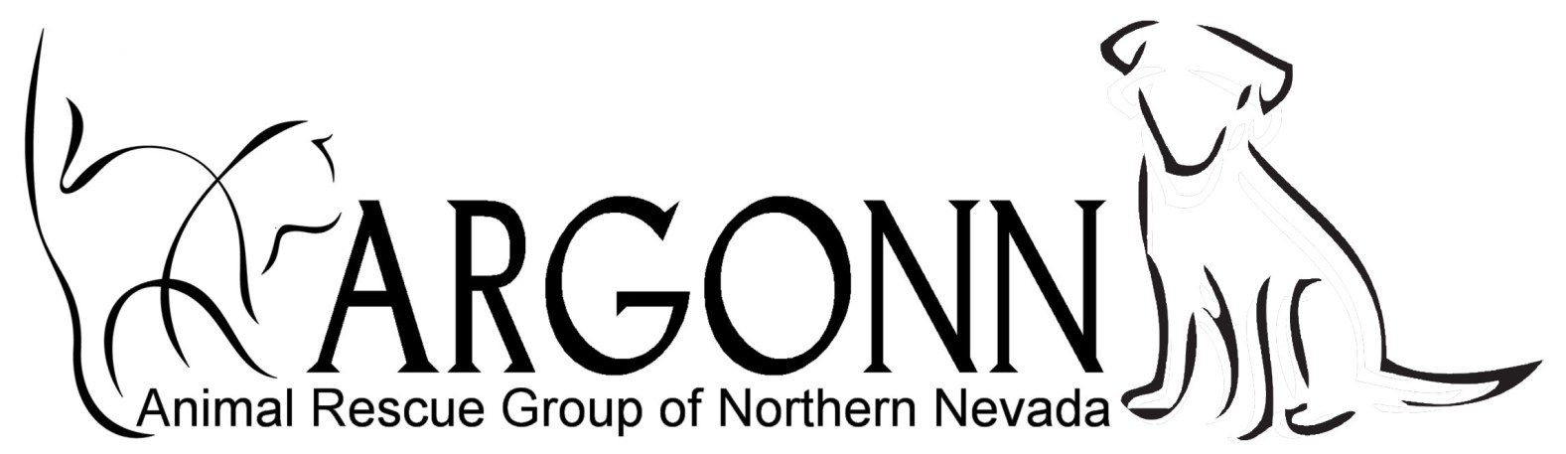
P.O Box 1, Fernley, NV 89408
775 229-3708 www.argonn.org

FOSTER HOME APPLICATION

NAME: __________________________________________________________________________

OTHER HOUSEHOLD MEMBERS: __________________________________________________

ADDRESS: ______________________________________________________________________

TEL: Home: ___________________ Cell: ____________________ Work: ___________________

Dog ____ How many? _______ Cat _____ How many? ______
Please tell us about your fostering facilities, for example indoor or outdoor and protection provided:

_________________________________________________________________________________

_________________________________________________________________________________
Will you be able to provide food and/or veterinary care for fostered animals?

Explain: _________________________________________________________________________

____________________________________ Vet name, tel: ________________________________
Please provide details about your existing or permanent pet population:

_________________________________________________________________________________

_________________________________________________________________________________
Please explain why you want to provide a foster home for abandoned or rescued animals:

_________________________________________________________________________________

_________________________________________________________________________________

I agree to foster dogs or cats and promise to:
- Accommodate these animals as detailed above and agreed to by ARGONN
- Provide humane care, including proper food, water, shelter, exercise, and competent veterinary care in the case of illness or injury.
- Hold harmless ARGONN, its directors and/or associates for any illness of the animal or injury or damage that the animal may do to any person or property.
- If I choose to adopt the animal in my foster care, I will pay to ARGONN the required adoption fee, and agree to spay/neuter the animal within 6 months of adoption.

Signed: _____________________________________ Date: _______________________________

Signature of ARGONN officer: ___________________________________ Date: ______________

