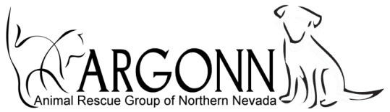
P.O. Box 1, Fernley, NV 89408
775 229-3708 www.argonn.org

APPLICATION FOR MEMBERSHIP

NAME: ____________________________________ Introduced by: _____________________

ADDRESS: ___________________________________________________________________

EMAIL: _____________________________ Internet activity (FB, Twitter) _______________

TEL: Home: ____________________ Cell: ______________________ Work: ______________

PETS: __________________________________ ___________________________________

__________________________________ ___________________________________

Interests and Hobbies: ___________________________________________________________

______________________________________________________________________________

Would you be interested in fostering? _____ Dog __________ Cat ________________

Are your pets spayed / neutered? ______________ If not, why not? ______________________

Do any of your pets come from a rescue facility? _____ Name: __________________________

Other rescue origin, please explain _________________________________________________

______________________________________________________________________________

Do you manage a feral cat colony? _________ How many cats? _________

How did you hear about ARGONN? _______________________________________________

Do you belong to any other animal rescue/protection organizations? _______________________

Signed: ___________________________________________ Date: ______________________

APPROVAL by MEMBERSHIP COMMITTEE.

Signed: ___________________________________________ Date: ______________________

Signed: ___________________________________________ Date: ______________________

This form and membership dues to be sent to Treasurer after membership committee approval.

______________________________________________________________________________

