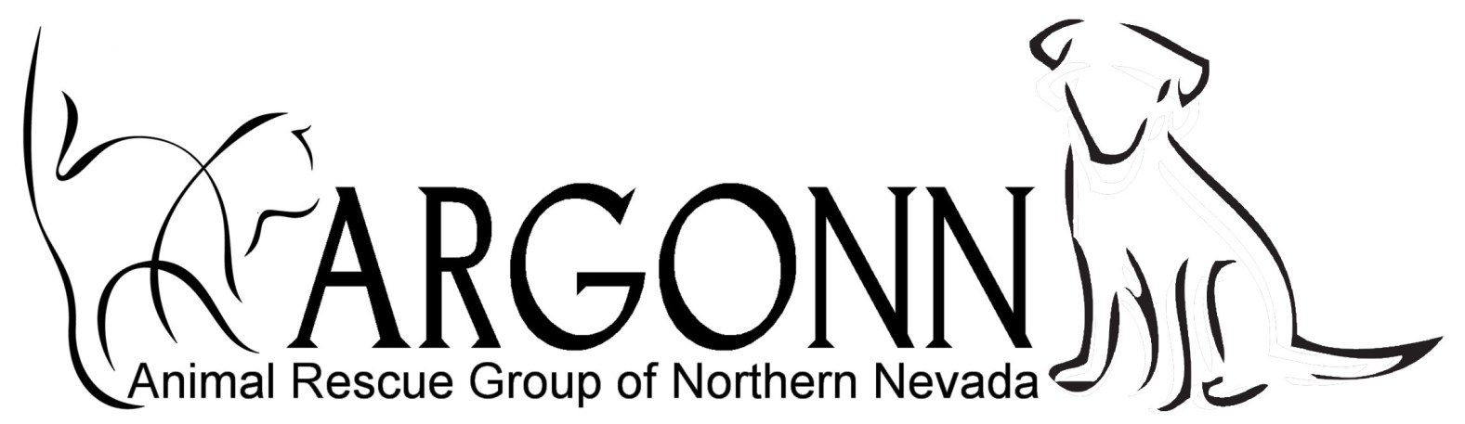
P.O. Box 1
Fernley, NV 89408
775 229-3708 www.argonn.org
ANIMAL ADOPTION CONTRACT

Date: ___________________ Associate: ____________________________________

Name: ___________________________________ Email: _______________________________________

Address: _________________________________ City: ______________ State: ____ Zip: _____________

Mailing Address: __________________________ City: ______________ State: ____ Zip: _____________

Home Phone: ___________________ Cell: ____________________ Work: _________________________
ANIMAL DESCRIPTION AND INFORMATION

Dog/Cat: ________ Sex: ______ Age: __________ Name: _______________________________________

Breed: ________________________ Color: ___________________ Other: _________________________
ANIMAL ADOPTION AGREEMENT

I acknowledge receipt from ARGONN, the above described animal and in consideration thereof, I solemnly promise and agree that:

_____ 1. If the animal does not prove satisfactory, or if for some reason I can no longer keep this animal, I understand that adoption fees are non-refundable and I agree to contact ARGONN immediately. I will not sell, give away, abandon or relinquish this animal to any person, society or group or permit it to be used for any experimental purposes.

_____ 2. I will accept this animal as a household pet and companion and will comply with all laws and ordinances in force in the area in which I reside. I will provide humane care, proper food, water, shelter, exercise and competent veterinary care in case of illness or injury to the described animal.

_____ 3. If animal is a cat, I agree that cat will NOT BE DECLAWED.

_____ 4. I agree to seek an annual veterinary check-up and keep current recommended vaccinations.

_____ 5. I agree to hold harmless ARGONN and its directors or associates for any illness of the animal or for any damage that the animal may do to any person or property.

_____ 6. I agree to an adoption fee of $ ___________ which includes spay/neuter and age appropriate vaccinations. This contract is considered complete and fully executed when I take possession of the animal.

Signed: __________________________________ Signed: _______________________________________

Place of Adoption: ________________________________________________________________________

