PROJECT KITTY KARE APPLICATION

Date ____________________

Name of owner _____________________________________________

Street address ______________________________________________

City _______________________ Zip ___________________

Mailing address (if different from above _________________________

City _______________________ Zip ___________________

Preferred phone # _______________________ Alternate phone # _____________________________

Email address (required) ______________________________________________

Number of cats (co-pay $20 each female, $10 each male) to be altered _____________

IF cat is up to date on Rabies shot attach proof to avoid over vaccinating, otherwise it will be included at time of surgery (at no cost to you) in accordance with Nevada State law.

1. Name of Cat ________________________ Age ____________ Breed/color ___________________

Sex (circle one) M F Date of last Rabies vaccination ________________________

For females only: Is the cat in heat or possibly pregnant? Circle one Y N

2. Name of Cat ________________________ Age ____________ Breed/color __________________

Sex (circle one) M F Date of last Rabies vaccination ________________________

For females only: Is the cat in heat or possibly pregnant? Circle one Y N

3. Name of Cat ________________________ Age ____________ Breed/color ___________________

Sex (circle one) M F Date of last Rabies vaccination ________________________

For females only: Is the cat in heat or possibly pregnant? Circle one Y N

Please initial the following statements to verify that each is true or that you give consent:

_______ [initial] I am the owner of the cat(s) described on this application and I am at least 18 years old. I am authorized to approve the services offered by ARGONN’s Project Kitty Kare.

_______ [initial] I understand that I am to make the vet appointment and advise the vet that this is an ARGONN Project Kitty Kare spay or neuter appointment. I also understand that I am responsible for transporting my cat(s) IN CARRIERS to and from the vet’s office.

_______ [initial] I understand that if my cat is discovered to be pregnant at the time of spaying, the procedure will continue without obtaining owner’s consent.

_______ [initial] I understand that if I want any services other than SPAY (female), NEUTER (male) or any additional medications or antibiotics, I will be responsible for payment of these services to the vet. After-care for my cat(s) is my responsibility as is the expense for any emergency resuscitation that I authorize. I agree to discuss this with the vet’s office prior to surgery.

_______ [initial] At the time I schedule the appointment, I will discuss with the vet’s office any other cat related issues I need to have addressed. I understand that these additional costs are my responsibility.

_______ [initial] I understand that if my cat(s) is/are abandoned at the Veterinary Office, I will be prosecuted to the full extent of the law and will have to pay any applicable court costs and attorney fees.

Your spay/neuter Voucher co-pay will be a total of $_________ for _______ cats. Payment by debit or credit card, money order or certified check. No personal checks will be accepted.

Signature of Owner _______________________________ Date _____________________________

To help you understand how Project Kitty Kare works, please read to the bottom of the page.

Once your application with proofs of Rabies vaccinations is received it will be reviewed and you will be contacted for payment of the co-pay amount if not included with your application. Your application is NOT the voucher. The voucher will be mailed to you after the application and proofs are received and you are approved by ARGONN. You cannot use this application at the vet’s office. If your application is not complete, an approval will be delayed until we can make contact with you. Be sure to initial and sign where indicated.

Please allow 2 weeks to receive your voucher in the mail.

ARGONN contact information:
By mail: V. Stuart, 6435 Hwy 95A, Silver Springs NV 89429
Email: argonn.org@gmail.com
Phone: 775 315-0017 (for Project Kitty Kare questions)
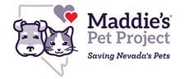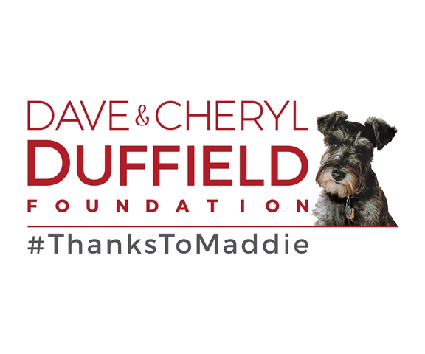
Grant funding from ARGONN’s participation in the Maddie’s® Pet Project in Nevada campaign is made possible by the generosity of the Dave & Cheryl Duffield Foundation, #ThanksToMaddie.

