Campfire
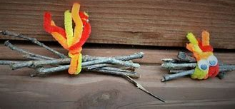
Materials: red, yellow, and orange pipe cleaner, one small safety pin per swap, scissors, tiny sticks
Instructions: Cut 2 inches of each color of pipe cleaner. Line the three colors up together, and twist one time around a bundle of sticks. Slide a safety pin through the back of the pipe cleaners!

