Popsicle
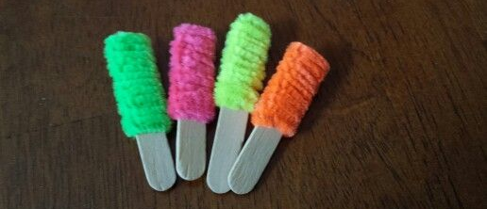
Materials: Pipe cleaners, Popsicle sticks, Safety Pins, Glue
Instructions: Cut the popsicle sticks in half. Thread the pipe cleaner through the "circle" of the safety pin and glue to the end of the pipe cleaner to the popsicle stick. Wrap the pipe cleaner around, leaving some stick.

