Lollipops
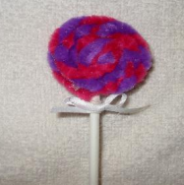
Materials: pipe cleaners, lollipop sticks, ribbon, safety pins
Instructions: Cut 2 pipe cleaners in half and twist together. Swirl them into a circle. Add glue to the back to help it hold its shape. Glue a lollipop stick to the back. Add ribbon for hanging and one for a bow.

