Caterpillars
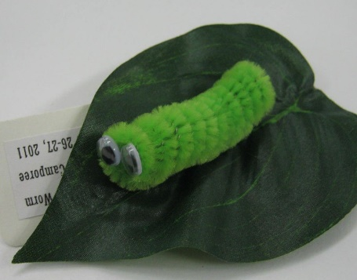
Materials: pipe cleaners, eyes, scissors, glue
Instructions: Take a pencil, pen, or finger and wrap the pipe cleaner tightly around to make a cylinder. Tuck the ends into the center of the cylinder. Glue on eyes for a cute face, and you can even get a fake leaf to glue on!

