Arrows
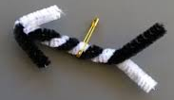
Materials: pipe cleaners, safety pins
Instructions: Twist two pipe cleaners together in the center leaving space on either end. At one end spread the pipe cleaners away from the base, at the other end bend the pipe cleaners down to create the arrowhead. Add safety pin to the center through a twist.

