Musical Note
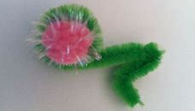
Materials: pipe cleaners, glue
Instructions: Bend pipe cleaner as shown in picture. Use glue to attach a small piece from another pipe cleaner in the middle.

