FORMAT & TIME AT THE BAYSWATER PETANQUE CLUB

8:30 AM FOR 9 AM START
COUPE
DE
FRANCE
OPEN TRIPLE
LMDF
30th Nov
9AM
VENUE MAY CHANGE IF MORE THAN 24 TEAMS REGISTER
*4 QUALIFYING ROUNDS SWISS 60 MINS + 1 END IF TIED
(* MAY CHANGE SUBJECT TO REGISTRATION NUMBERS)
TOP 8 TEAMS DIRECT TO ELIMINATION FINALS –
1ST VS 2ND 3RD VS 4TH FINAL UNTIMED IN MAIN AND CONVIVIAL
TEAMS 9TH TO 16TH PLAY IN THE CONVINIAL ELIMINATION FINALS
UMPIRE OF THE DAY – ERIC CARBONELL
LUNCH
BYO LUNCH 30 min after 4th round
Drinks Sold by BWPC
Cakes, tea, and coffee for sale
REGISTRATION $30 PER PLAYER ON ARRIVAL
ERIC CARBONELL 0430 859 308
ericcarbonell@y7mail.com
www.mypetanque.com.au
REGISTRATIONS CLOSE 5 PM 27TH NOVEMBER

PRIZES (AMOUNT TBA)
1st PLACE Main + Convivial
2nd PLACE Main + Convivial
3rd PLACE Main + Convivial
NO RANKING POINTS
AWARDED FOR THIS COMP

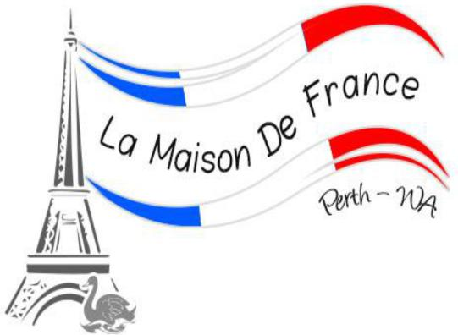

LMDF ARE TRIALING THIS FORMAT TO HAVE A LARGE $$ EVENT IN THE YEAR, SO GET BEHIND IT AND SUPPORT THE CONCEPT AS
YOU ALL HAVE BEEN ASKING FOR THIS ON OUR CALENDAR.
ALL SPECTATORS ARE WELCOME, TEAMS KNOCKED OUT. PLEASE STAY AND CHEER FOR THOSE PLAYING IN THE FINALS

