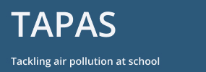

Application Form: TAPAS Collaboration Building Workshop
9-24 September 2021

Title, Name:

Institution/Organisation:

Research Area/Profession

Can you attend all the constituent events of the workshop?

Yes No
Brief career summary (Max 100-words):

Why would you like to attend the workshop? (Max 100-words)

Please email this form to Sophy Bristow by COB July 30, 2021.

