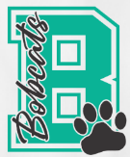
GrandGrams!
Orders due by Friday, April 3, 2026
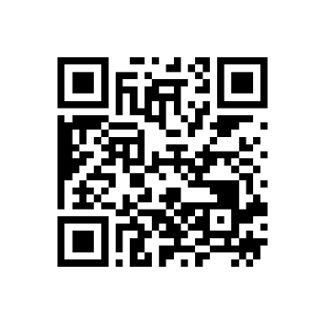
We know there are many grandparents who are unable to attend our annual Grandparents event. That’s why we created GrandGram: a special package filled with goodies along with a message from you that will be delivered directly to your grandchild’s classroom on Grandparents Day. Limited quantities are available so be sure to get your form in early to secure a GrandGram!
Ordering Options:
- Complete this form: paying with check or exact cash
- Online: https://bucklakeshop.square.site/s/shop
or scan QR code
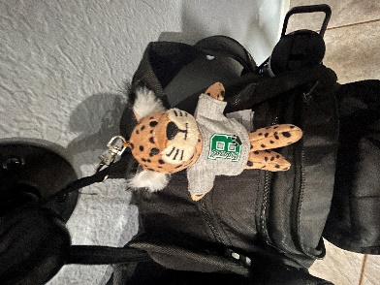
GrandGram will include:
- Kids Meal Coupon from Chick-fil-A
- Nuberri Ice Cream Coupon – Free Cup
- Customized Bobcat Backpack Buddy (pictured here)
- Assorted candy
- Most importantly a personal message from you!

Total Number of GrandGrams: x $20 per GrandGram = $

NOTE: If you are purchasing more than one GrandGram, please fill out the second page of this form with student’s name, grade, teacher and personalized message.

Exact cash required. If paying by check, please make payable to Buck Lake Elementary.
Questions, please contact: Buck Lake Elementary PTO bucklakepto@gmail.com

Student’s Name: ________________________________________________________________

Homeroom Teacher: _________________________________ Grade: _____________________

Personalized Message:

Redeem the Chick-fil-A Kids Meal Coupon at the NE location – 3101 Capital Circle NE
Complete this page only if you are purchasing more than one GrandGram. Please be sure this page is submitted along with the payment information on page 1.

Orders due by Friday, April 3, 2026

Student’s Name: ________________________________________________________________

Homeroom Teacher: _________________________________ Grade: _____________________

Personalized Message:

Redeem the Chick-fil-A Kids Meal Coupon at the NE location – 3101 Capital Circle NE

Student’s Name: ________________________________________________________________

Homeroom Teacher: _________________________________ Grade: _____________________

Personalized Message:

Redeem the Chick-fil-A Kids Meal Coupon at the NE location – 3101 Capital Circle NE

