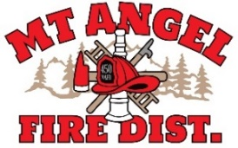
BOARD OF DIRECTORS MEETING AGENDA
300 Monroe St., Mt. Angel
Date: February 17, 2026, at 7:00 pm

Call MEETING TO ORDER/ROLL CALL
FLAG SALUTE
APPROVAL OF AGENDA: Approval
MINUTES: December 11, 2025 Approval

PUBLIC COMMENT:

SECRETARY TREASURER’S REPORT: Information
- Columbia Bank: $31,172.96
- LGIP: $673,956.94

INFORMATION ITEMS
- Building and Site Update
- Consolidation Update

ACTION ITEMS
- Conflagration Resolution (01.26)
- Oktoberfest grant Resolution-Unanticipated Revenue (02.26)
- WM Annen Family Foundation Resolution-Unanticipated Revenue (03.26_
- Adopt Budget Calendar for FY 2026-2027

CHIEFS REPORT

NEXT MEETING: March 12, 2026, at 7 pm
The meeting location is accessible to people with disabilities. A request for accommodation for persons with disabilities should be made at least 48 hours before the meeting by calling Mt. Angel Fire District at 503-845-2438.

