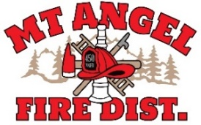
BOARD OF DIRECTORS MEETING AGENDA
300 Monroe St., Mt. Angel
Date: December 11, 2025, at 7:00 pm

Call MEETING TO ORDER/ROLL CALL
FLAG SALUTE
APPROVAL OF AGENDA: Approval
MINUTES: November 20, 2025, at 7 pm Approval

PUBLIC COMMENT:

SECRETARY TREASURER’S REPORT: Information
- Columbia Bank: $145,445.40
- LGIP: $875,840.52

INFORMATION ITEMS
- Building and Site Update
- Consolidation Update
- Fire Chief time away in January

ACTION ITEMS
- Second Reading and Adopt Revisions to Board Policies (BP 101, #6 and BP 102 #3)
- Resolution to formalize board approval to dissolve Mt Angel Fire District (place holder)
- Resolution to formalize $1.97 per thousand of new Mt Angel Monitor Fire District (place holder)

CHIEFS REPORT

NEXT MEETING: January 8, 2025, at 7 pm
The meeting location is accessible to people with disabilities. A request for accommodation for persons with disabilities should be made at least 48 hours before the meeting by calling Mt. Angel Fire District at 503-845-2438.

