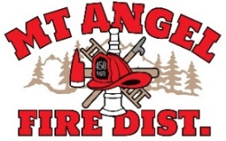

**BOARD OF DIRECTORS MEETING AGENDA**

**300 Monroe St. Mt. Angel**

**Date: October 10, 2024 at 7 pm**

Call MEETING TO ORDER/ROLL CALL

FLAG SALUTE

APPROVAL OF AGENDA: Approval

MINUTES: September 5, 2024 Approval

PUBLIC COMMENT:

SECRETARY TREASURER’S REPORT: Information

* Columbia Bank: $36,190.66
* LGIP: $783,589.88

INFORMATION ITEMS

* Audit review with Kori Sarrett
* Storage building update

ACTION ITEMS

CHIEFS REPORT

NEXT MEETING: November 14, 2024 at 7pm

*The meeting location is accessible to persons with disabilities. To request accommodation, call Mt. Angel Fire District at 503-845-2438 at least 48 hours before the meeting.*