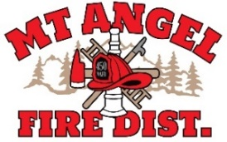
BOARD OF DIRECTORS MEETING AGENDA
300 Monroe St., Mt. Angel
Date: April 14, 2026 at 7 pm

Call MEETING TO ORDER/ROLL CALL
FLAG SALUTE
APPROVAL OF AGENDA: Approval
MINUTES: March 12, 2026 Approval

PUBLIC COMMENT:

SECRETARY TREASURER’S REPORT: Information
- Columbia Bank: $22,406.31
- LGIP: $597,322.28

INFORMATION ITEMS
- Consolidation Update

ACTION ITEMS

CHIEFS REPORT

NEXT MEETING: May 14, 2026, BUDGET COMMITTEE MEETING!
The meeting location is accessible to people with disabilities. A request for accommodation for persons with disabilities should be made at least 48 hours before the meeting by calling Mt. Angel Fire District at 503-845-2438.

