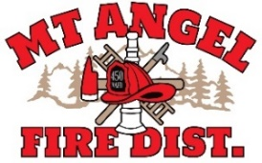
BOARD OF DIRECTORS MEETING AGENDA
300 Monroe St., Mt. Angel
Date: July 16, 2026 at 7 pm

CALL MEETING TO ORDER/ROLL CALL
FLAG SALUTE
APPROVAL OF AGENDA: Approval
MINUTES: June 11, 2026 Approval

PUBLIC COMMENT:

SECRETARY TREASURER’S REPORT: Information
- Columbia Bank: $11,603.56
- LGIP: $501,469.59

INFORMATION ITEMS
- Consolidation Update
- Building and Site Fund-Proposed Renaming and Change of Purpose Discussion

ACTION ITEMS
- Dissolution Resolution 05.26

CHIEFS REPORT

NEXT MEETING: August 13, 2026 at 7 pm
The meeting location is accessible to people with disabilities. A request for accommodation for persons with disabilities should be made at least 48 hours before the meeting by calling Mt. Angel Fire District at 503-845-2438.

