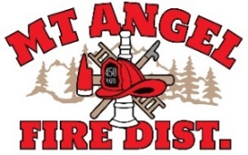

**BOARD OF DIRECTORS MEETING AGENDA**

**300 Monroe St. Mt. Angel**

**Date: August 14, 2025 at 7pm**

Call MEETING TO ORDER/ROLL CALL

FLAG SALUTE

APPROVAL OF AGENDA: Approval

MINUTES: June 12, 2025 at 7pm Approval

PUBLIC COMMENT:

SECRETARY TREASURER’S REPORT: Information

* Columbia Bank: $6,587.94
* LGIP: $779,708,.68

INFORMATION ITEMS

* Building and Site Update
* Mt. Angel Fire/Monitor Fire Consolidation Update
* Board Members and Fire District Volunteers-General Discussion
* OSHA Required Organizational Statement
* Building and Site Fund Continuation Resolution

ACTION ITEMS

* Swear in Directors
* Election of Officers
* Adopt Pay Policy
* Adopt Unemployment Policy

CHIEFS REPORT

NEXT MEETING: September 11, 2025 at 7pm *THIS IS DURING OKTOBERFEST

*The meeting location is accessible to people with disabilities. A request for accommodation for persons with disabilities should be made at least 48 hours before the meeting by calling Mt. Angel Fire District at 503-845-2438.*