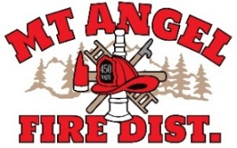

**BOARD OF DIRECTORS MEETING AGENDA**

**300 Monroe St. Mt. Angel**

**Date: December 12, 2024 at 7 pm**

Call MEETING TO ORDER/ROLL CALL

FLAG SALUTE

APPROVAL OF AGENDA: Approval

MINUTES: November 14, 2024 Approval

PUBLIC COMMENT:

SECRETARY TREASURER’S REPORT: Information

* Columbia Bank: $24,359.58
* LGIP: $1,238,300.97

INFORMATION ITEMS

* Review Board Policies
* Vector Solutions Board Member Training

ACTION ITEMS

* Office Flooring
* Revision of Resolution 04-16
* Storage Building Bids

CHIEFS REPORT

NEXT MEETING: January 9, 2024 at 7pm

*The meeting location is accessible to persons with disabilities. To request accommodation, call Mt. Angel Fire District at 503-845-2438 at least 48 hours before the meeting.*