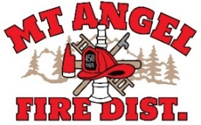

**BOARD OF DIRECTORS MEETING AGENDA**

**300 Monroe St. Mt. Angel**

**Date: August 6, 2024 at 7 pm**

Call MEETING TO ORDER/ROLL CALL

FLAG SALUTE

APPROVAL OF AGENDA: Approval

MINUTES: July 11, 2024 at 7 pm Approval

PUBLIC COMMENT:

SECRETARY TREASURER’S REPORT: Information

* Columbia Bank: $41,107.33
* LGIP: $921,243.03

INFORMATION ITEMS

ACTION ITEMS

* Review Proposals for Building

CHIEFS REPORT

NEXT MEETING: September 12, 2024 at 7 pm

*The meeting location is accessible to persons with disabilities. A request for accommodations for person with disabilities should be made at least 48 hours before the meeting by calling Mt. Angel Fire District at 503-845-2438.*