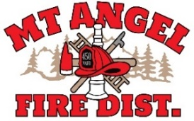
BOARD OF DIRECTORS MEETING AGENDA
300 Monroe St. Mt. Angel
Date: September 16, 2025 at 7:00 pm

Call MEETING TO ORDER/ROLL CALL
FLAG SALUTE
APPROVAL OF AGENDA: Approval
MINUTES: August 14, 2025 at 7pm Approval

PUBLIC COMMENT:

SECRETARY TREASURER’S REPORT: Information
- Columbia Bank: $41,354.91
- LGIP: $725,468.38

INFORMATION ITEMS
- Building and Site Update
- Consolidation Update (Follow-up from Joint Meeting)
- Review Board Policies-Definition of a Volunteer and Honorary
- Review Board Policy on Consecutive Terms as President, Vice President, and Treasurer
- Conflagration Revenue Update
- Up-Staffing Report

ACTION ITEMS
- Adopt OSHA Organizational Statement
- Building and Site Fund Continuation Resolution

CHIEFS REPORT

NEXT MEETING: October 9, 2025 at 7pm
The meeting location is accessible to people with disabilities. A request for accommodation for persons with disabilities should be made at least 48 hours before the meeting by calling Mt. Angel Fire District at 503-845-2438.

