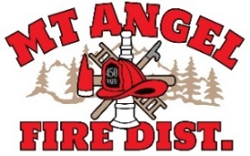

**BOARD OF DIRECTORS MEETING AGENDA**

**300 Monroe St. Mt. Angel**

**Date: November 14, 2024 at 7 pm**

Call MEETING TO ORDER/ROLL CALL

FLAG SALUTE

APPROVAL OF AGENDA: Approval

MINUTES: October 10, 2024 Approval

PUBLIC COMMENT:

SECRETARY TREASURER’S REPORT: Information

* Columbia Bank: $59,916.52
* LGIP: $773,030.50

INFORMATION ITEMS

* SDAO Best Practices
* Building update
* OFDDA

ACTION ITEMS

* Updating Resolution 04-16-Rules for Cost Recovery

CHIEFS REPORT

NEXT MEETING: December 12, 2024 at 7pm

*The meeting location is accessible to persons with disabilities. To request accommodation, call Mt. Angel Fire District at 503-845-2438 at least 48 hours before the meeting.*