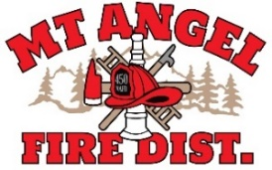
BOARD OF DIRECTORS MEETING AGENDA
300 Monroe St., Mt. Angel
Date: November 20, 2025, at 7:00 pm

Call MEETING TO ORDER/ROLL CALL
FLAG SALUTE
APPROVAL OF AGENDA: Approval
MINUTES: October 9, 2025, at 7 pm Approval
SPECIAL MEETING MINUTES: November 4, 2025 at 6:30 pm Approval

PUBLIC COMMENT:

SECRETARY TREASURER’S REPORT: Information
- Columbia Bank: $12,701.44
- LGIP: $557,664.77

INFORMATION ITEMS
- Audit Review with Kori Sarrett
- Building and Site Update
- Consolidation Update

ACTION ITEMS
- Adopt Revisions to Board Policies

CHIEFS REPORT

NEXT MEETING: December 11, 2025, at 7 pm
The meeting location is accessible to people with disabilities. A request for accommodation for persons with disabilities should be made at least 48 hours before the meeting by calling Mt. Angel Fire District at 503-845-2438.

