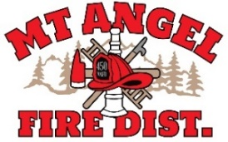
BOARD OF DIRECTORS MEETING AGENDA
300 Monroe St. Mt. Angel
Date: October 9, 2025, at 7:00 pm

Call MEETING TO ORDER/ROLL CALL
FLAG SALUTE
APPROVAL OF AGENDA: Approval
MINUTES: September 16, 2025, at 7 pm Approval

PUBLIC COMMENT:

SECRETARY TREASURER’S REPORT: Information
- Columbia Bank: $29,967.64
- LGIP: $574,572.79

INFORMATION ITEMS
- Building and Site Update
- Consolidation Update
- Review Draft Board Policy Revisions

ACTION ITEMS

CHIEFS REPORT

NEXT MEETING: November 13, 2025, at 7 pm
The meeting location is accessible to people with disabilities. A request for accommodation for persons with disabilities should be made at least 48 hours before the meeting by calling Mt. Angel Fire District at 503-845-2438.

