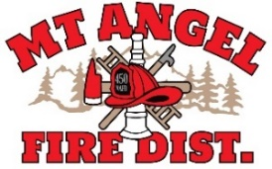
BOARD OF DIRECTORS MEETING AGENDA
300 Monroe St., Mt. Angel
Date: March 12, 2026, at 7:00 pm

Call MEETING TO ORDER/ROLL CALL
FLAG SALUTE
APPROVAL OF AGENDA: Approval
MINUTES: February 17, 2026 Approval

PUBLIC COMMENT:

SECRETARY TREASURER’S REPORT: Information
- Columbia Bank: $12,097.32
- LGIP: $679,279.61

INFORMATION ITEMS
- Building and Site Update
- Consolidation Update

ACTION ITEMS
- Appoint Budget Officer for the 2026-2027 Fiscal Year

CHIEFS REPORT

NEXT MEETING: April 9, 2026, at 7 pm
The meeting location is accessible to people with disabilities. A request for accommodation for persons with disabilities should be made at least 48 hours before the meeting by calling Mt. Angel Fire District at 503-845-2438.

