Manuscript Title

First Author¹, Second Author² , Other Author(s)
¹Affiliation and email address of First Author and other Author(s) (if applicable)
²Affiliation and email address of First Author and other Author(s) (if applicable)

Other Author(s)
Affiliation and email address of other Author(s) (if applicable)
Abstract Begin each manuscript with an abstract that summarizes the content of the manuscript in 150 to 250 words. The abstract will appear online at SpringerLink and be available with unrestricted access to facilitate online searching, using, e.g., Google, and allow unregistered users to read the abstract as a teaser for the complete chapter. Don’t include reference citations or undefined abbreviations in the abstract, since abstracts are often read independently of the actual chapter and without access to the reference list. Please also add two to four keywords. Each keyword should not contain more than two compound words, and each keyword phrase should start with an uppercase letter. When selecting the keywords, think of them as terms that will help someone locate your chapter at the top of the search engine list using, for example, Google. Very broad terms (e.g. ‘Case study’ by itself) should be avoided as these will result in thousands of search results but will not result in finding your chapter.
Keywords First keyword, Second keyword,Third keyword,Fourth keyword.

1 First Section
This template is based on the Springer Author Template T1-book(T1-book.dot), and was prepared to help structure your manuscript, e.g., define the heading hierarchy. Predefined style formats are available for all the necessary structures that are supposed to be part of the manuscript [1].
Use only the styles contained in this template to format your manuscript. Remember not to make changes that involve only matters of style when you check your proofs.
For a detailed description on how to use the T1-book template see the file readme-T1-book.pdf.
1.1 Manuscript length
The manuscript length, including tables, figures and references, should not exceed 10 pages, in the format of this template.

2 Manuscript preparation
Either British or American English can be used, but be consistent within your manuscript. Check for consistent spelling of names, terms and abbreviations, including in tables and figure legends.
For American spelling please consult Merriam–Webster's Collegiate Dictionary; for British spelling you should refer to Collins English Dictionary.
If English is not your native language, please ask a native speaker to help you or arrange for your text to be checked by a professional editing service. Please insert their final corrections into your data before submitting the manuscript.

2.1 Headings andHeading Numbering
Heading levels should be clearly identified using this template, and each level should be uniquely and consistently formatted and numbered using the decimal system. Never skip a heading level.
Headings have no end punctuation or period after the heading number. All major words in a heading are capitalized. Articles, conjunctions, and prepositions that are four letters or less in length, are not capitalized.

2.1.1 Heading Levels
Up to three numbered heading levels should be used within a paper (H1, H2 and H3). Displayed headings must always keep to the hierarchical sequence. For example, it is not possible to use a heading 3 immediately after a heading 1.
Run-in headingsIn addition to numbered headings, one more “Run-in” heading level is possible.Run-in headings are set immediately at the beginning of the paragraph and should be formatted in bold. Proceed as follows: after writing the text of the heading, insert two blank spaces and press the “NoFormat” button (Ctrl + Spacebar) before continuing with the text to eliminate any special formatting for the rest of the paragraph.

2.1.2 Cross referencing
In cross-references, for hyperlink purposes, please refer to the section number (e.g., see Sect. 3.5.1), not to the page.

2.2 Terminology, Units and Abbreviations
Technical terms and abbreviations should be defined the first time they appear in the text. Always use SI units (http://physics.nist.gov/cuu/Units/).
Numerals should follow the British/American method of decimal points to indicate decimals and commas to separate thousands. If the manuscript contains a large number of terms and abbreviations, a list of abbreviations or a glossary is advised.

2.2.1 Emphasis and Special Type
Italics should be used for emphasized words or phrases in running text. Do not format entire paragraphs in italics. Bold formatting should not be used. Sans serif (e.g., Arial) and non-proportional fonts (e.g., Courier) can be used to distinguish the literal text of computer programs from running text.
Please avoid footnotes or endnotes.

2.2.2 Equations
Use Microsoft Equation Editor to create your equations, and insert the graphic into your text file as an object.Displayed equations are numbered, with the equation number to the right of the equation. For example, the Euler equation is written as follows:
(1)
where e is Euler's number, the base of natural logarithms, j is the imaginary unit, which satisfies j² = −1, and π is pi, the ratio of the circumference of a circle to its diameter.
Within equations, numbers,punctuation, parentheses, common function names, units, or mathematical signs are set upright; variables are set in italics, e.g. E*(jω), and vectors are set in bold. If the equation is part of a sentence, punctuation follows normal language rules.
Text references to equations take the forms “Eq. 6”or “Eqs. 6 – 8”.

2.3 Tables
Give each table a heading (caption). Add a reference to the table source at the end of the caption if necessary. Number tables consecutively (e.g. Table 1, Table 2, etc.) and ensure that all tables are cited in the text in sequential order. Do not write “the following table”.
Use the table function to create and format tables. Do not use the space bar or multiple tabs to separate columns and please do not use Excel to create tables as this can cause problems when converting your tables into the typesetting program and other formats.
Do not manually insert table rules in the manuscript, because they cannot be retained.
Table 1Table captions have no end punctuation and no period after the table number
 | Column1 | Column2 | Column3 | Column4
Row1
Row2
Row3

Simple, one-column lists should not be treated as tables. Use the displayed list function instead:
- Ad montemIuram, qui fines Sequanorum ab Helvetiisdividit
- Eodem die ab exploratoribuscertiorfactushostessub monte consedissemiliapassuum ab ipsiuscastrisocto, qualisessetnaturamontis.
- Renuntiatumestfacilemesse.
- Ubiea dies quamconstituerat cum legatisvenit et legatiadeumreverterunt
- Negat se more et exemplo populi Romani posse iterulli per provinciamdare et.

2.4 Figures
Give each figure a concise caption, describing accurately what the figure depicts. Number figures consecutively (e.g. Figure 1, Figure 2, etc.) and ensure that all figures are cited in the text in sequential order. Do not write “the following figure”. If a figure is reproduced from a previous publication, include the source as the last item in the caption.
Please consider a minimum size of 2 mm (6 pt) for text within a figure. Use lowercase letters for part figure labels.

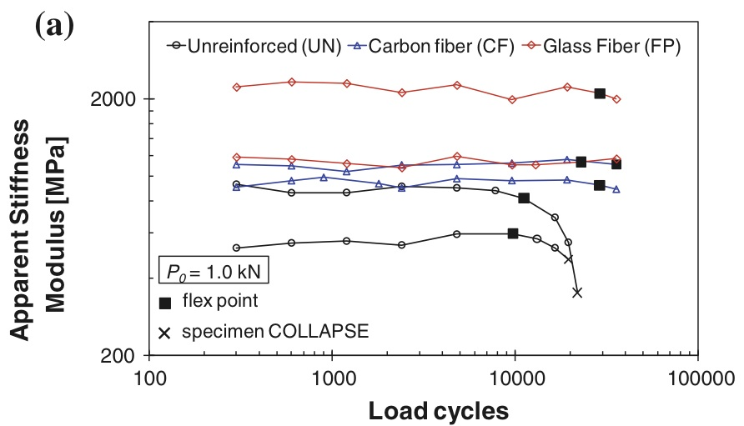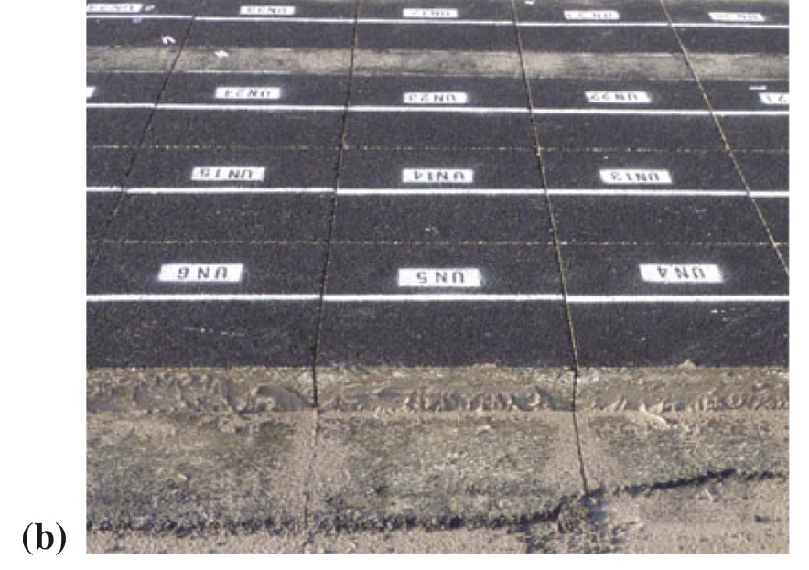
Fig. 1Figure captions have no end punctuation and no period after the figure number: a) First part of the figure, b) Second part of the figure
Color figures will appear in color in the eBook but will be printed in black and white, therefore make sure that the interpretation of graphs does not depend on color.
2.5 References
Cite references in the text with author name/s and year of publication in parentheses (“Harvard system”):
- One author: (Miller 1991) or Miller (1991)
- Two authors: (Miller and Smith 1994) or Miller and Smith (1994)
- Three authors or more: (Miller et al. 1995) or Miller et al. (1995)
2.5.1 Reference list
Include a reference list at the end of the paper. Include all works that are cited in the text and that have been published (including on the internet) or accepted for publication. Personal communications and unpublished works should only be mentioned in the text. Do not use footnotes as a substitute for a reference list.
Entries in the list must be listed alphabetically. The rules for alphabetization are:
- First, all works by the author alone, ordered chronologically by year of publication
- Next, all works by the author with a coauthor, ordered alphabetically by coauthor
- Finally, all works by the author with several coauthors, ordered chronologically by year of publication
AcknowledgementsThe activity presented in the paper is part of the research grant …
References
Example references are listed below.
- Journal article
[1] Sokolov, A. N., Roberts, M. E., & Bao, Z. (2009). Fabrication of low-cost electronic biosensors. Materials today, 12(9), 12-20.

- Book, authored
[1] South J, Blass B (2001) The future of modern genomics. Blackwell, London

- Book chapter
[1] Brown B, Aaron M (2001) The politics of nature. In: Smith J (ed) The rise of modern genomics, 3rd edn. Wiley, New York, p 234–295

- Paper presented at a conference
[1] Chung S-T, Morris RL (1978) Isolation and characterization of plasmid deoxyribonucleic acid from Streptomyces fradiae. Paper presented at the 3rd international symposium on the genetics of industrial microorganisms, University of Wisconsin, Madison, 4–9 June 1978

- Online document
Doe J (1999) Title of subordinate document. In: The dictionary of substances and their effects. Royal Society of Chemistry. Available via DIALOG. http://www.rsc.org/dose/title of subordinate document. Accessed 15 Jan 1999

