**BANSTEAD’s**

**BEST FRONT GARDEN 2023**

**HANGING BASKET COMPETITION**

**Sponsored by Banstead Horticultural Society**

**Free Entry**

Top Prize £35

Certificates of Merit awards

Full details and application over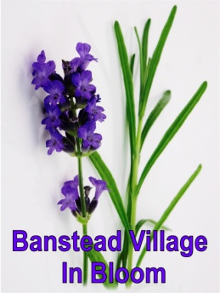

**Rules**

**The Garden** must be within 1 mile of All Saints Church, and visible to passers-by. Gardens with high hedges/fences will be judged from the front gate. Nearby Street untidiness may be a deciding factor. We will take two looks in the year.

**Judging** takes place **weeks commencing June 4th and September 3rd**

**Awards and Prize Giving** On September 16th at our Autumn show from 5pm the overall winner and merited winners will be presented with their prizes at Banstead Community Hall, Park Road. Free show entry to competitors.

**Hanging baskets** which must be visible at the front of the house will be judged just once, prior to our July show on the **17th and 18th July**.

|  |
| --- |
| FINALE**Banstead’s Best Front Garden** |
| Name/s: |
| Garden Address |
| Phone |
| Send to: Banstead Horticultural Society,  Inyoni, De Burgh Park, Banstead SM7 2PR  01737351224 or email peterkend@aol.com  **closing date for applications 31st May** |
|  |
| **Application form** |
| **Banstead’s Best hanging basket** |
| Name/s: |
| Garden Address |
| Phone |
| Send to: :Banstead Horticultural Society,  Inyoni, De Burgh Park, Banstead. SM7 2PR  017137351224 or [emailpeterkend@.com](mailto:emailpeterkend@.com)  **Closing date for applications 30th June** |
|  |
|  |