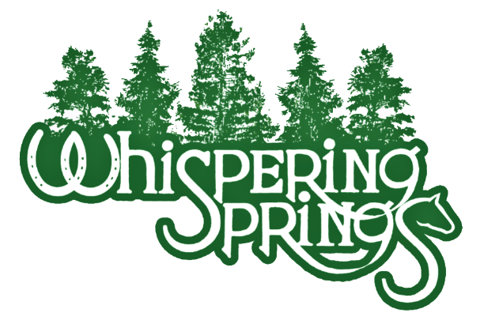
Birthday Parties at Whispering Springs Horse Farm

COWBOY/COWGIRL BIRTHDAY PARTY PACKAGE
$350 FOR UP TO 10 KIDS
Includes:
- 2 large pizzas, soda, and paper products
- 15-minute horseback/pony ride per child
- Picture time with horses and western themed backdrop
- Horsin’ around games (western bean bag toss, pin the tail on the horse, horse crafts, etc)
- $5 off coupon for one trail ride
*Parents can provide a cake and party favors, if desired
*Each parent will be required to sign a release form when their child arrives
*Each rider must wear closed toed shoes and a helmet
*Approximate length of party is 2 hours
*A non-refundable deposit of $100 will be required at the time of booking.
Note: We are able to accommodate birthday parties in some inclement weather (ie. Rain). However, if weather does not permit, we will notify you and give the option to reschedule at a later date.
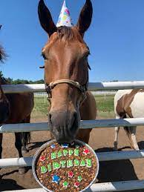
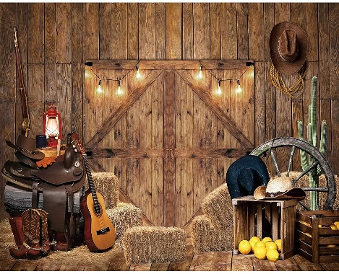

Please complete the information below and return, along with a $100 deposit to Whispering Springs Horse Farm – 4884 Alder Dr., Walnutport, PA 18088:
Name of Parent: ______________________________________________________________________
Address: _____________________________________________________________________________
Phone Number: _______________________________________________________________________
Email: _______________________________________________________________________________
Birthday Child’s Name: ________________________________________________________Age: _____
Date of Party: ____________________________ Time of Party: ___________________________

