Faith Missionary Baptist Church
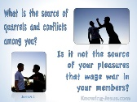
BIBLE STUDY
[Tuesday & Wednesday]
March 31, 2020

LESSON 4
James 4:1-17

Lust Is The Source of Wars and Strife

INTRODUCTION
The world is in turmoil all over the globe. There are neighbors at war. There are families at war. There are nations at war. There is a war going on in the streets of our cities. Why is there so much tension and strife? James in our lesson today gives us the answer. The war and strife all boil down to one word-lust.
Lust is a killer of relationships on every level. Worst of all lust is a killer of our relationship to God. We lust for what others have. We lust for power. We lust for position. We lust for wealth. We lust for honor and recognition and the list goes on and on. We lust for sex with someone outside of the confines of the God designed institution of marriage.
There are many in our world today who will go to any measure or extreme to get what they want. They will steal, kill, undermine and whatever it takes to get what they want. 1 Kings chapter 21:1ff. gives us a perfect example of how destructive lust is when they lusted for a man’s vineyard and set him up to be killed in order to possess it. They took Naboth’s vineyard, but they did not live to enjoy it. God intervened and sent judgment on them. According to James, that is wrong. I’ve known Christians in the body of Christ try to undermine another person’s position.

1st Reading-James 4:1-3……………………………………..…….War and Strife Comes From Lust
A. Question: Where does war and fighting come from?
B. Answer in the second question: come they not from lust from the inner man?
C. You lust, you kill, and you desire to obtain.
D. You fight and war but do not have.
E. You don’t ask God for what you need.
F. Ye ask with the wrong motive-good request but motive is wrong
G. You are asking out of want not need.

2nd Reading- James 3:4-5, ……………………………Following The World’s System Separates Us From God
A. Adulterers and adulteresses, Question: Do you not know friendship with the word is separation from God.
B. Friends of the world are enemies of God. (World means the world system)
C. Do not think the scripture is in error.
D. The spirit that dwell in us lusteth to envy.

3rd Reading- James 3:6-7………………………………………………………..…More Grace To The Humble
A. God gives more grace to the humble (unmerited favor)
B. He says, God resists the proud. (See also 1Peter 5:5)
C. Submit or give yourselves to God. (Mind, body, soul, plans) See also Romans 12:1-2
D. Resist of shun the devil.
E. The devil will flee if you resist. (Don’t entertain the devil’s propositions)

4th Reading James 3:8-9, …………………………………………The Prescription For Getting Close To God
A. The proposition and the promise: Draw close to God-He will draw close to you
B. Clean up your hearts and hands.
C. Ye double-minded-ones who are not settled in your faith
D. Be afflicted, turn laughter to mourning, turn joy to heaviness=show remorse for sin.
(See Psalm 51:17, Isa. 57:15)

5th Reading James. 3:10-12-:………………………………………Humble Yourself And Refrain From Judging
A. The charge to be humble is repeated.
B. How to humble yourself-in the sight of the Lord-He is watching you.
C. The promise: He will lift you up. (Example: See Luke 18:9-14)
D. Speak not evil of one another: (See Matthew 7:1-5)
E. There is one lawgiver or (judge)
F. God can save or destroy-He has the power and authority.
G. Challenging Question: Who are you that judges another? (Are you qualified to judge?)

6th Reading-James 3:13-15……………………………………………..……A Word To Boasters About Big Plans
A. Watch out for saying, “Today or tomorrow we will go here, and do thus for a year
B. ‘We will have this or have that.”
C. Tomorrow is uncertain to you.
D. Penetrating Question: What is your life?
E. Answer: Your life is a vapor-appears, the vanishes.
F. Correction: What you should say, “If the Lord will, we will live, and do this or that.”
G. Involve and consult God about your plans.

7th Reading-James 3:16-17…………………………………………To Know What’s Good And Do It Not Is Sin
A. To rejoice in boasting is evil.
B. Why? Boasting does not consider God’s will
C. Knowledge of good must be acted upon o tie would be sin.
D. This kind of sin is called- sin of commission.
E. Sins of commission is just as harmful as sins of omission.
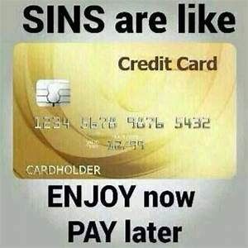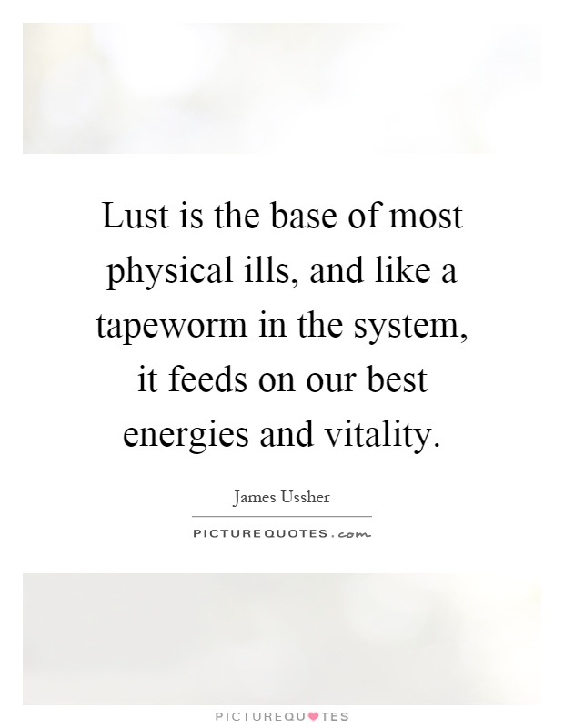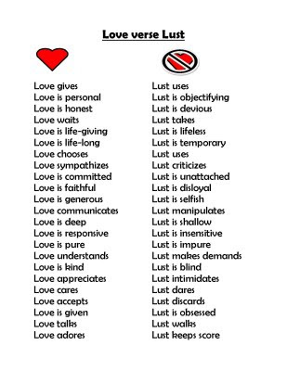

Spiritual Application: Apply This Lesson To Your Life Today
1. Humility is of utmost importance in our relationship to God and our fellow man.
2. Friendship with the world is separation from God. See 1 John 2:15
3. God desires that we draw close to him. (He does not want distancing.)
4. To draw close to God we must clean up.
5. Life is short and tomorrow is not promised.
6. _______________________________________________
7.________________________________________________
MEMORY VERSES: “Draw nigh to God, and he will draw nigh to you. Cleanse your hands, ye sinners; and purify your hearts, ye double minded. Be afflicted, and mourn, and weep: let your laughter be turned to mourning, and your joy to heaviness.”
------James 4:8-9

