Faith Missionary Baptist Church
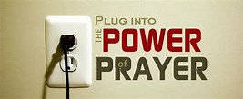
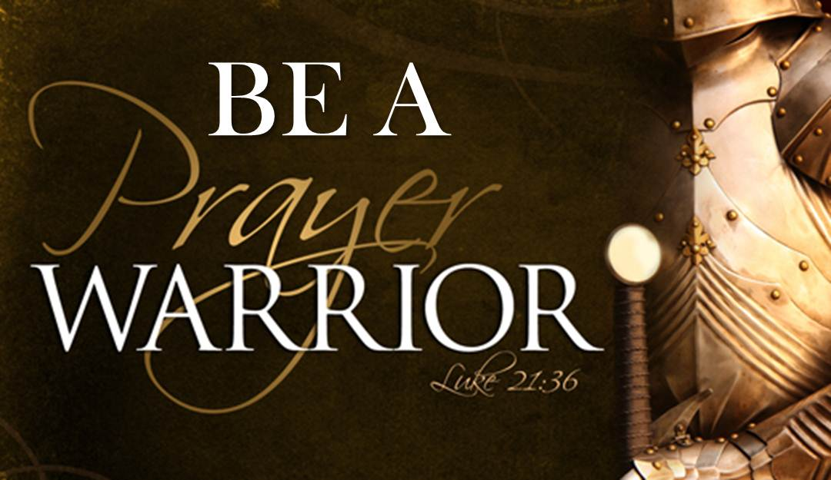
BIBLE STUDY
[Tuesday & Wednesday]
April 7-8, 2020

LESSON 5
James 5:1-20

Prayer Is Our Most Powerful Weapon

INTRODUCTION

There are many forms of power in the world today. There is electrical power, which gives us light and power to operate our appliances in our homes and businesses. There is green power which is the power to buy goods and services based on the money we have in our pockets or in the bank. There is water power that flows from ponds, streams, rivers, lakes, and oceans. There is political power which enables politicians to do certain things that ordinary citizens cannot do. There is horsepower, which gives our cars, trucks, boats, and other vehicles power to carry us or to do work for us. There is military power available to our soldiers to have at their disposal bombs, missiles, and other weapons for attacking the enemy. There are many other sources of power that are too numerous to mention; but all these sources of power put together cannot match nor surpass the power of prayer.
Prayer is the most powerful weapon of them all. We as Christians have at our disposal the most powerful weapon in the 'world for attacking the enemy- prayer. Yet many of us don’t use it. Many of us only use it in emergencies. In today’s lesson we are going to examine the power of prayer in the life of Christians.

1st Reading-James 5:1-3……………………………………..………..….The Vanity of Ill Gained Riches
A. Watch out rich people
B. Calamity is ahead for you
C. Your riches will corrode
D. Moth will eat up your clothes

2nd Reading- James 5:4-6, ……………………………………Boomerang: Your Injustice Will Fall BACK On You
A. Charge: You failed to pay your workers
B. The Lord has heard the cry of those you cheated.
C. Your selfishness will work against you
D. You will be like cattle to be slaughtered.
E. Charge: You condemned and killed innocent people

3rd Reading- James 5:7-8………………………………………………………..…Be Patient For The Lord’s Return
A. Brethren: term of Christian affection
B. Be patient for the Lord’s return
C. Example: Farmers wait for the autumn and spring rain to grow their crops.
D. Be patient like the farmer
E. The Lord is coming soon

4th Reading James 5:9-10, ………………………………………….……… Don’t Grumble Against Each Other
F. Follow the example of the prophets who spoke for the Lord.
G. The prophets were patient in suffering

A. Brethren: Term of Christian affection
B. Don’t grumble against each other
C. You will be judged by the judge.
D. The judge is at the door (close by).
E. Brethren: Term of Christian affection.

5th Reading James. 5:11-12-:…………………………………………………..…Happy Are Those Who Endure
A. We praised the ones who endured
F. Don’t take oaths: not by heaven, not by earth
G. Let your yes be yes and your no be no
H. You will be condemned if you say anything more

B. Mention of the patience of Job
C. The Lord showed Job mercy
D. The Lord delivered Job because he is merciful and kind
E. Brethren: Term of Christian affection

6th Reading-James 5:13-16……………………………………Prayer Is The Most Powerful Weapon Of A Christian
A. Question: Who’s afflicted or going through a painful experience?
B. Response: Pray
C. Question: Who’s merry?
D. Response: Sing psalms
E. Question: Who’s sick?
F. Response: Call for the elders of the church, let them pray, anointing with oil, in the name of the LORD.
- Elders may be deacons or designated spiritual leaders of the church.
- Oil represents the Holy Spirit. Oil is a point of contact.
G. Confess or admit to one another your faults so you can be healed.
H. The effectual fervent(hot) prayer availeth much.

7th Reading-James 5:17-18…………………………………………………The Prophet Elijah Was A Man of Prayer
A. Elijah was a man with passions like us. D. He prayed again for rain.
B. He prayed that it not rain. E. The rain came
C. It did not rain for three and a half years.

8th Reading-James 5:19-20………………………………………………………Correcting One Another From Error
A. Help one another stay on tract
B. Correcting one another saves one from death (spiritual death or backsliding)
C. Their sins will be forgiven
A
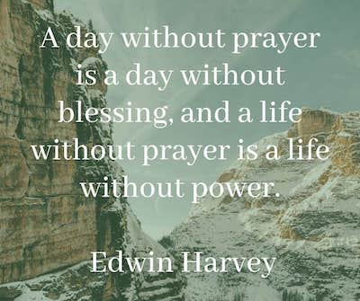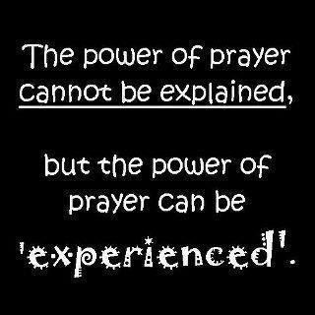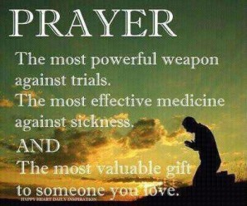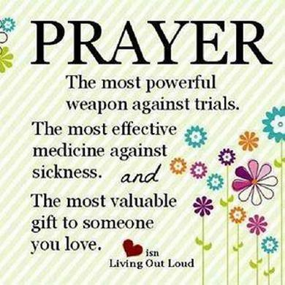
E.

Spiritual Application: Apply This Lesson To Your Life Today
1. We need to plug into the power of prayer.
2. Prayer still works.
3. Prayer and faith goes together like hand and glove.
4. Ill gained riches will soon pass away.
5. PUSH=Pray Until Something Happens
6. _______________________________________________
7.________________________________________________
MEMORY VERSES: “Confess your faults one to another, and pray one for another, that ye may be healed. The effectual fervent prayer of a righteous man availeth much.” --James 5:16

