9:30 a.m. The Second Sunday after the Epiphany Yr. C January 16, 2022

The Reverend Susan E. Kerr Mr. Alan Newman
Minister and Pastor Organist and Music Director

- Please rise, in body or in spirit. Bold words indicate unison participation.
*Indicates liturgical materials used from Seasons of the Spirit©

OUR APPROACH TO GOD

ORGAN PRELUDE “Prelude and Fugue in C Major” Johann S. Bach “Lord of the Dance” arr. John Behnke
“Fairest Lord Jesus” arr. Diane Bish

CHIMES AND ANNOUNCEMENTS

CONGREGATIONAL INTROIT (INSERT) “HOLY GROUND”

RESPONSIVE CALL TO WORSHIP Psalm 36:5-10
L: Your steadfast love, O LORD, extends to the heavens, your faithfulness to the clouds.
ALL: Your righteousness is like the mighty mountains, your judgments are like the
great deep; you save humans and animals alike, O LORD.
L: How precious is your steadfast love, O God! All people may take refuge in the
shadow of your wings.
ALL: They feast on the abundance of your house, and you give them drink from the
river of your delights.
L: For with you is the fountain of life; in your light we see light.
ALL: O continue your steadfast love to those who know you, and your salvation to
the upright of heart!

UNISON GATHERING PRAYER*
Extravagant God, we gather in this sacred space,
guests at a feast of Your boundless gifts.
Stretch out Your canopy of grace--
Your sheltering wings--
that we may delight in Your love,
which never runs out. Amen.

SALUTATION AND SHARING of the Peace (Remain seated.)
L: Peace be with you! ALL: AND ALSO WITH YOU!

HYMN #187 “JESUS, COME! FOR WE INVITE YOU”

CHILDREN’S MESSAGE

PRAYER OF CONFESSION*
Hospitable God, we confess that, from time to time, we hold back
the very best we have to offer of our resources and ourselves.
We may not want to get involved and risk opening our hearts,
risk giving away too much, risk encountering You in both the giving and receiving.
Encourage us to take a chance – to think and dream outside the lines.
Dare us to reach out our hands to both give and receive Your outpouring grace.
(Pause for a time of silent prayer.)

KYRIE ELEISON (sung) #297
Spirit of the living God, fall a-fresh on me;
Spirit of the living God, fall a-fresh on me;
Melt me, mold me, fill me, use me.
Spirit of the living God, fall a-fresh on me.

WORDS OF ASSURANCE
God is the gracious Welcomer who offers us the very best
and gives abundantly so, not only can we count our blessings,
but we can share them with all.
ALL: Thanks be to God! Amen.

THE LAW OF GOD

- GLORIA PATRI #805
Glory be to the Father and to the Son and to the Holy Ghost! As it was in the
beginning, is now and ever shall be, world without end; Amen, Amen.

THE WORD OF GOD
PRAYER FOR ILLUMINATION

SCRIPTURE READINGS Isaiah 62:1-5 John 2:1-11

SERMON HYMN #190 “SONGS OF THANKFULNESS AND PRAISE” (please remain seated)

SERMON “Signs and Miracles” The Rev. Susan E. Kerr

OUR RESPONSE TO GOD

THE WORSHIP OF GIVING: OUR OFFERINGS TO GOD

- DOXOLOGY #809 (The Worshiping Church hymnal)
“Praise God from whom all blessings flow. Praise God all creatures here below.
Praise God above, ye heavenly host: Praise Father, Son and Holy Ghost. Amen.”

- Prayer of Dedication of our Gifts and Tithes

PRAYERS OF THE PEOPLE AND THE LORD’S PRAYER
Our Father, who art in heaven, Hallowed be thy name. Thy kingdom come. Thy will be
done on earth as it is in heaven. Give us this day our daily bread, and forgive us our
debts, as we forgive our debtors, and lead us not into temptation, but deliver us from
evil. For thine is the kingdom, and the power, and the glory, forever. Amen.

- HYMN #718 “STIR YOUR CHURCH, O GOD, OUR FATHER”

- BENEDICTION

POSTLUDE “Praise to the Lord, the Almighty” arr. Diane Bish

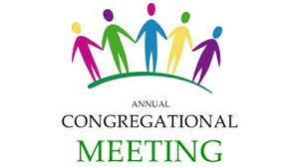

You are invited to join us in the Auditorium for our Annual Meeting
today following worship.

THE CONSISTORY OF OLD NORTH
Elders: Karen DiBella (2022) Scott Benell (2023) Carol Sushko (2023, 2nd term)
Deacons: Betsy Erhard (2021) Brianna Polbos (2021)
John Passarotti (2022) Richard Schmude (2023)
Minister: Rev. Susan Kerr (Parsonage) 201-338-8237; revskerr@gmail.com

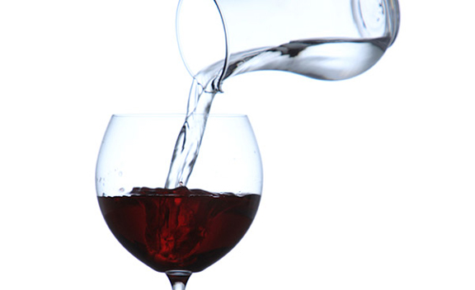

SIGNS AND MIRACLES

Old North Reformed Church
120 Washington Avenue, Dumont, New Jersey 07628
201-385-2243 oldnorthdumont@gmail.com
https://oldnorth.church

Welcome to worship at Old North Reformed Church!
If you would like to be added to our mailing list, please leave your contact
information in the guest book before leaving today.

We encourage you to keep this copy of the liturgy and take it home to
share with a member of your family, or with a friend.

“In the Reformed Church, baptism is always performed in the context of a congregation of God’s people. Baptism is primarily an act of God, showing grace toward us, and only secondarily an expression of our commitment to God. The Reformed tradition believes that scripture teaches that baptism has replaced circumcision, a Hebrew rite that marked the covenant between God and God’s people.”

Prayer Chain: If you would appreciate adding the power of prayer to uplift in times of celebration, healing, or transitions in life, please call Pat Hooey, 201-843-4456.

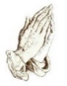
Church Family Prayer List:
●Barbara ●Jeanne ●Katie ●Michael
Those with chronic conditions and their loving care-givers; those undergoing medical
procedures and those who are recovering; those in mourning; those fighting cancer; and those
seeking spiritual and emotional well-being.

If you are able to host one Sunday, the sign up
sheet is available during Coffee Hour.

Join Pastor Susan on Wednesdays for 11 a.m. Lectionary Bible Study.
We meet in the Church House Lounge. All are welcome!
Bring your own Bible or use one of ours.
There will be no Bible Study on 1/19/22 & 1/26/22.
Participants are required to be fully vaccinated.

Congratulations to all of our Church Family who are celebrating a special event!
Happy Birthday!
1/3 Danielle Toscano 1/6 Megan Passarotti
1/12 Eric Frolich 1/19 Jackie Toscano
1/23 Karen Minkler 1/29 Richard Bennewitz
Happy Anniversary!
1/9 James & Cheryl Rodgers

Thrift Shoppe volunteers appreciated Tuesday mornings between
9:30-11:30 a.m. Come share the fun!

Food Drive: Thank you to Scott Benell and our volunteers for weathering the cold yesterday to continue our Food Drives!

Annual Congregational Meeting: Today in the Auditorium following worship.

2022 Church Directory: The new church directory will be available in the Auditorium during Coffee Hour/Annual Meeting. Please help yourself to one per household.

Egg Cartons & Shopping Bags: Old North continues to collect empty 1 dozen egg cartons along with plastic and paper shopping bags for the Dumont Food Pantry. The Pantry receives their eggs in bulk and this helps them to distribute them to local families. There is a bin in the Church House hallway. If you have any questions, contact the office.

If you have a pastoral need or wish to contact Pastor Susan, you may call the
parsonage at 201-338-8237 or the church, and leave a message.
Her cell phone number is 201-983-7008.
If you are “not sure” whether or not you should call—please call!
Note that Pastor Susan’s day off is Monday, but call in an emergency.
Pastor Susan will be on vacation from 1/17/22 - 1/31/22.
We welcome the Reverends Jodie Wu and Phyllis Palsma into our pulpit.
In case of pastoral emergency please contact an elder.

