9:30 a.m. The Third Sunday after the Epiphany Yr. C January 23, 2022

The Reverend Susan E. Kerr Mr. Alan Newman
Minister and Pastor Organist and Music Director

- Please rise, in body or in spirit. Bold words indicate unison participation.
*Indicates liturgical materials used from Seasons of the Spirit©

OUR APPROACH TO GOD

ORGAN PRELUDE “Rondeau” Jean Joseph Mouret “For All the Saints” Gerhard Krapf
“Leaning on the Everlasting Arms” A.J. Showalter

CHIMES AND ANNOUNCEMENTS

CONGREGATIONAL INTROIT (INSERT) “HOLY GROUND”

RESPONSIVE CALL TO WORSHIP Psalm 19
L: The heavens are telling the glory of God; and the firmament proclaims
his handiwork.
ALL: Day to day pours forth speech, and night to night declares knowledge.
L: There is no speech, nor are there words; their voice is not heard;
ALL: yet their voice goes out through all the earth, and their words to the end
of the world.
L: In the heavens he has set a tent for the sun, which comes out like a bride-groom
from his wedding canopy, and like a strong man runs its course with joy.
ALL: Its rising is from the end of the heavens, and its circuit to the end of them; and
nothing is hid from its heat.
L: The law of the LORD is perfect, reviving the soul; the decrees of the LORD are sure,
making wise the simple;
ALL: the precepts of the LORD are right, rejoicing the heart; the commandment of the
LORD is clear, enlightening the eyes;
L: the fear of the LORD is pure, enduring forever; the ordinances of the LORD are
true and righteous altogether.
ALL: More to be desired are they than gold, even much fine gold; sweeter also than
honey, and drippings of the honeycomb.
L: Moreover by them is your servant warned; in keeping them there is great reward.
ALL: But who can detect their errors? Clear me from hidden faults.

L: Keep back your servant also from the insolent; do not let them have dominion over me. Then I shall be blameless, and innocent of great transgression.
ALL: Let the words of my mouth and the meditation of my heart be acceptable to you,
O LORD, my rock and my redeemer.

UNISON GATHERING PRAYER Based on the prayer of St. Richard of Chichester.
Dear God, for these three things we pray:
to love You more dearly, see You more clearly,
and follow You more nearly every day. Amen.

SALUTATION AND SHARING of the Peace (Remain seated.)
L: Peace be with you! ALL: AND ALSO WITH YOU!

HYMN #2 “Holy, Holy, Holy! Lord God Almighty”

CHILDREN’S MESSAGE

PRAYER OF CONFESSION*
All: In our humanity, we sometimes become set in our ways.
In our fear, we can be reluctant to break out of familiar routines.
In our complacency, we are not always willing to try new things.
God, for all the times when we have cut off the dreams, hopes, or
imaginings of your reign, we are truly sorry. (Time of personal reflection.)

KYRIE ELEISON (sung) #297
Spirit of the living God, fall a-fresh on me;
Spirit of the living God, fall a-fresh on me;
Melt me, mold me, fill me, use me.
Spirit of the living God, fall a-fresh on me.

WORDS OF ASSURANCE John 3:16-17
L: Believe this Gospel and go forth to live in peace.
All: Thanks be to God!

THE LAW OF GOD

- GLORIA PATRI #805
Glory be to the Father and to the Son and to the Holy Ghost! As it was in the
beginning, is now and ever shall be, world without end; Amen, Amen.

THE WORD OF GOD
PRAYER FOR ILLUMINATION

SCRIPTURE READINGS 1 Corinthians 12:12-31a

SERMON HYMN #115 “Fairest Lord Jesus” (please remain seated)

SERMON “Being the Body of Christ” The Rev. Jodie Wu

OUR RESPONSE TO GOD

THE WORSHIP OF GIVING: OUR OFFERINGS TO GOD

- DOXOLOGY #809 (The Worshiping Church hymnal)
“Praise God from whom all blessings flow. Praise God all creatures here below.
Praise God above, ye heavenly host: Praise Father, Son and Holy Ghost. Amen.”

- Prayer of Dedication of our Gifts and Tithes

PRAYERS OF THE PEOPLE AND THE LORD’S PRAYER
Our Father, who art in heaven, Hallowed be thy name. Thy kingdom come. Thy will be
done on earth as it is in heaven. Give us this day our daily bread, and forgive us our
debts, as we forgive our debtors, and lead us not into temptation, but deliver us from
evil. For thine is the kingdom, and the power, and the glory, forever. Amen.

HYMN #708 “Blest Be the Tie that Binds”

- BENEDICTION

POSTLUDE Finale on “Italian Hymn” Van Denman Thompson

We welcome the Rev. Jodie Wu. Rev. Wu is co-pastor at Bogart Memorial Reformed Church. She is a graduate of Hope College, Fuller Seminary, and Duke Divinity School. She lives in Bogota, NJ with her husband and two children.

THE CONSISTORY OF OLD NORTH
Elders: Karen DiBella (2022) Scott Benell (2023) Carol Sushko (2023, 2nd term)
Deacons: Brianna Polbos (2021) John Passarotti (2022) Richard Schmude (2023)
Minister: Rev. Susan Kerr (Parsonage) 201-338-8237; revskerr@gmail.com

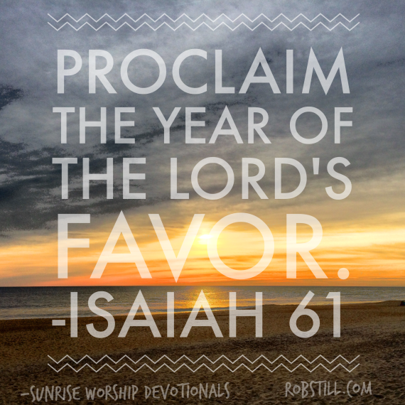

Old North Reformed Church
120 Washington Avenue, Dumont, New Jersey 07628
201-385-2243 oldnorthdumont@gmail.com
https://oldnorth.church

Welcome to worship at Old North Reformed Church!
If you would like to be added to our mailing list, please leave your contact
information in the guest book before leaving today.

We encourage you to keep this copy of the liturgy and take it home to
share with a member of your family, or with a friend.

The Consistory of Old North presents the following
members that will continue to serve.
Brianna Polbos has been re-elected to serve for a second term:
Elders: Karen DiBella (2022), Scott Benell (3-yr. term, 2023)
Carol Sushko (second 3-yr. term, 2023)
Deacon: John Passarotti (2022), Richard Schmude (3-yr. term, 2023),
Brianna Polbos (second 3-yr term, 2025)
Minister: Rev. Susan Kerr
We thank Betsy Erhard and Leslie Maro for their faithful service on Consistory.

Prayer Chain: If you would appreciate adding the power of prayer to uplift in times of celebration, healing, or transitions in life, please call Pat Hooey, 201-843-4456.

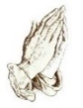
Church Family Prayer List:
●Barbara ●Jeanne ●Katie ●Michael
Those with chronic conditions and their loving care-givers; those undergoing medical
procedures and those who are recovering; those in mourning; those fighting cancer; and those
seeking spiritual and emotional well-being.

If you have a pastoral need or wish to contact Pastor Susan, you may call the
parsonage at 201-338-8237 or the church, and leave a message.
Her cell phone number is 201-983-7008.
Note that Pastor Susan’s day off is Monday, but call in an emergency.
Pastor Susan will be on vacation from 1/17/22 - 1/31/22.
We welcome the Reverends Jodie Wu and Phyllis Palsma into our pulpit.
In case of pastoral emergency please contact an elder.

Join Pastor Susan on Wednesdays for 11 a.m. Lectionary Bible Study.
We meet in the Church House Lounge. All are welcome!
Bring your own Bible or use one of ours. There will be no Bible Study on 1/26/22.
Participants are required to be fully vaccinated.

Congratulations to all of our Church Family who are celebrating a special event!
Happy Birthday!
1/3 Danielle Toscano 1/6 Megan Passarotti
1/12 Eric Frolich 1/19 Jackie Toscano
1/23 Karen Minkler 1/29 Richard Bennewitz
Happy Anniversary!
1/9 James & Cheryl Rodgers

Our Next Thrift Shoppe will be on 2/5/22 from 9 a.m. - 2 p.m.
Thrift Shoppe volunteers appreciated Tuesday mornings between
9:30-11:30 a.m. Come share the fun!

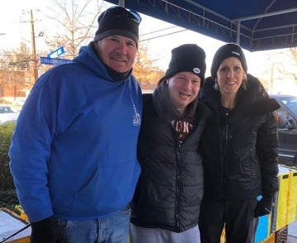
Food Drive: Thank you to Scott Benell, Karen DiBella, Rich, Marianne, Nate and Mikayla Schmude, for weathering the cold to continue our Food Drives! Our next Food Drive is Souper Bowl Saturday, 2/12/22. 9 a.m. - 12 p.m.

Annual Congregational Meeting: If you were unable to attend and would like a copy of the report, please contact the office.

2022 Church Directory: The new church directory is available in the Auditorium during Coffee Hour. Please help yourself to one per household.

Egg Cartons & Shopping Bags: Old North continues to collect empty 1 dozen egg cartons along with plastic and paper shopping bags for the Dumont Food Pantry. The Pantry receives their eggs in bulk and this helps them to distribute them to local families. There is a bin in the Church House hallway. If you have any questions, contact the office.

If you are able to host one Sunday, the sign up sheet is available during Coffee Hour, or you may contact the office.

