**9:30 a.m. The Fifth Sunday in Lent, Year A March 29, 2020**

The Reverend Susan E. Kerr Mr. Alan Newman

Minister and Pastor Organist and Music Director

* **Bold words indicate unison participation.**

* Indicates material used from Seasons of the Spirit ©.

**OUR APPROACH TO GOD**

PRELUDE <https://www.youtube.com/watch?v=TzejzO8ag2k>

*“Down in the River” trad. arr. Larry Nickel Shenandoah Christian Music Camp*

WELCOME AND ANNOUNCEMENTS

### CALL TO WORSHIP based on Psalm 130 (NIV-UK)

Leader: Out of the depths I cry to You, O Lord;

**ALL: O Lord, hear my voice. Let Your ears be attentive**

**to my cry for mercy.**

L: If You, O Lord, kept a record of sins, O Lord, who could stand?

**ALL: But with You there is forgiveness; therefore You are honored.**

L: I wait for the Lord, my soul waits, and in Christ’s word

I put my hope.

**ALL: My soul waits for the Lord more than watchmen wait for**

**the morning, more than watchmen wait for the morning!**

L: O People, put your hope in the Lord, for with Jesus is unfailing

love and with him is full redemption.

**ALL: Jesus himself will redeem us from all our sins!**

### UNISON GATHERING PRAYER

**Almighty God, your Son came into the world to free us all from sin and death. Breathe upon us with the power of your Spirit, that we may be raised to new life in Christ, and serve you in holiness and righteousness all our days, through the same Jesus Christ, our Lord, who lives and reigns with you in the unity of the Holy Spirit, one God, forever and ever. Amen.**

SALUTATION AND **Passing of the Peace**

Leader: Peace be with you; **ALL:** **AND ALSO WITH YOU.**

* **HYMN # 295 “BREATHE ON ME, BREATH OF GOD”**

https://www.youtube.com/watch?v=M5keJHZdWYM

CHILDREN’S MESSAGE

Invitation and **PRAYER of Confession\***

**O Lord, there are times when I forget to go to You**

**for the help I need.**

**I neglect to trust You to hear my cries, and I block out**

**the possibility that You will even listen.**

**My own inadequacies keep me from approaching You with what I need, and I forget that in You I will find hope and help.**

**Help me, O Lord, bring to You the needs of my spirit, so that You can fill my emptiness. Help me to trust in Your love, and sooth my soul with Your forgiveness.**  (silent contemplation)

ASSURANCE OF PARDON

Hope in God. For in God you will find steadfast love and eternal compassion. God is filled with power, and the Spirit of God is renewing the world even as we speak. **AMEN!**

THE LAW OF GOD

* GLORIA PATRI #805

***Glory be to the Father and to the Son and to the Holy Ghost!***

***As it was in the beginning, is now and ever shall be,***

***world without end; Amen, Amen.***

**THE WORD OF GOD**

### PRAYER FOR ILLUMINATION and SCRIPTURE LESSONS

### Old Testament: Ezekiel 37:1-14

## Leader: The Word of God. Response: Thanks be to God.

### Gospel: John 11:1-45

### Leader: The Gospel of Jesus Christ. ALL: Praise to you, O Christ.

**SERMON HYMN** **# 543 “CHRIST BESIDE ME”**

<https://www.youtube.com/watch?v=KNkWoy5uVh8>

SERMON “What Comes Next?” The Rev. Susan E. Kerr

**OUR RESPONSE TO GOD**

THE WORSHIP OF GIVING: OUR OFFERINGS TO GOD

*We are thankful to and grateful for all who continue to provide your offerings in support of Old North and her ministries by dropping off or mailing your envelopes.*

*Offerings may also be given via our website by PayPal or*

*credit card, at https://oldnorth.church*

DOXOLOGY

**“Praise God from whom all blessings flow.**

**Praise God all creatures here below.**

**Praise God above, ye heavenly host:**

**Praise Father, Son and Holy Ghost. Amen.”**

* Dedication of our Gifts and Tithes

PRAYERS OF THE PEOPLE AND THE LORD’S PRAYER

*Our Father, who art in heaven, Hallowed be thy name.*

*Thy kingdom come. Thy will be done on earth as it is in heaven. Give us this day our daily bread, and forgive us our debts, as we forgive our debtors, and lead us not into temptation, but deliver us from evil. For thine is the kingdom, and the power, and the glory, forever. Amen.*

* **HYMN “THE SERVANT SONG”**

https://www.youtube.com/watch?v=fkwdYAnOTdg

POSTLUDE <https://www.youtube.com/watch?v=fa8w7mGug0c>

*“I Will Rise” by Chris Tomlin*

THE CONSISTORY OF OLD NORTH

Elders: Gay Gravina (2022), Carol Sushko (2020), Leslie Maro (2020),

Karen DiBella (2022)

Deacons: Betsy Erhard (2021), Brianna Polbos (2021), Ralph Condis (2022), John Passarotti (2022)

Minister: Rev. Susan Kerr (Parsonage) 201-338-8237; [revskerr@gmail.com](mailto:revskerr@gmail.com)

Please visit our website at <https://oldnorth.church>

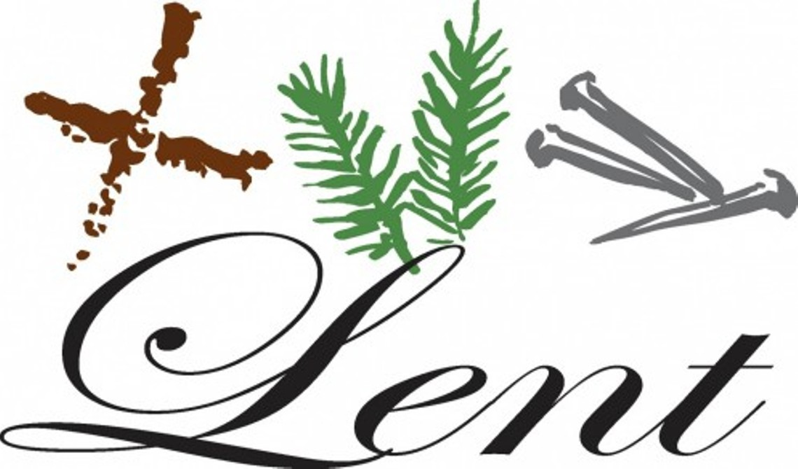

Old North Reformed Church

120 Washington Avenue, Dumont, New Jersey 07628

201-385-2243 [oldnorthdumont@gmail.com](mailto:oldnorthdumont@gmail.com)

Website - https://oldnorth.church

**Welcome to Old North Reformed Church Worship.**

**We encourage you to share** **this Liturgy with your household.**



Congratulations to all of our Church Family who are

celebrating a special event in April!

4/3 Richard Suson - 4/4 Scott Benell - 4/5 Ray Suson

4/5 Eleanor Woerner - 4/8 Rich Schmude - 4/12 Linda Treacy

4/16 Tiffany Sanders - 4/17 Aidan Kenny

4/23 Ashton DiBella - 4/25 Kay Hughes - 4/30 Terry Kenny



**Easter Flowers:** We will continue to collect Easter Flower Dedications for our Easter bulletin and celebration. Please get your dedication to the office by Monday 3/30.

**Prayer Chain:** If you have a celebration or concern that you would like to have included on our prayer chain, please call Pat Hooey, 201-843-4456.

**Church Family Prayer List**:

Katie Caspare Audrey Gallagher Barbara Porter

William Sanders

**Those with health concerns; emergency and first responder’s; police and**

**military personnel; those facing medical procedures or recovering from**

**surgery; those in mourning; all seeking spiritual well-being.**



**Holy Week and Easter**

**4/10 Good Friday/Stations of the Cross (Sanctuary)**

**Self-Directed Stations 10:00 a.m. - 7:00 p.m.**

**4/12 Easter Sunrise Service w/Bagpipes -**

**Gather at the Cross 6:00 a.m.**

**Easter Family Service 9:30 a.m.**

**For current updates link to Old North’s website, or our public Facebook page. (oldnorthdumont), or call the office and someone will get back to you as soon as possible.**

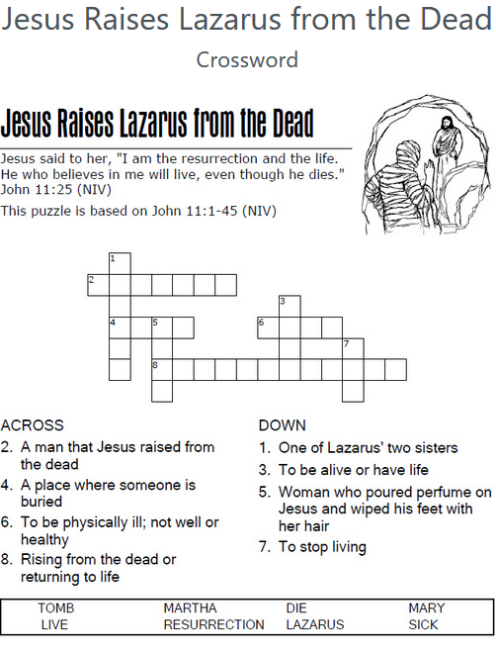

From Thru-the-Bible Coloring Pages for Ages 4-8. © 1986,1988 Standard Publishing.

Used by permission. Reproducible Coloring Books may be purchased from

Standard Publishing, www.standardpub.com, 1-800-543-1301.